WEB APPLICATION DEVELOPMENT
HOMEWORK ONE REPORT

Mine Equipment Health Monitor
A single-page condition-monitoring interface for smart mining


Student: Erlangga Rahmansyah (林安嘉)
Student ID: 202411070200

Class: 2024 Software Engineering
Lecturer: Assoc. Prof. 原桂远 (Yuán Guìyuǎn)
Submission: Wednesday, 30 September 2026

BACHELOR DEGREE OF SOFTWARE ENGINEERING
COLLEGE OF COMPUTER SCIENCE AND ENGINEERING
SHANDONG UNIVERSITY OF SCIENCE AND TECHNOLOGY
2026

Abstract
Rotating machines carry the production of an open-pit mine, and most of their mechanical faults raise vibration long before the machine fails. Reading that vibration correctly, however, depends on the machine's foundation type, the direction of measurement, and whether the value is drifting. This report describes the Mine Equipment Health Monitor, a single web page built with HTML, an internal CSS stylesheet, and plain JavaScript. It shows the vibration condition of six machines, draws a zone-banded trend for each, previews the severity zone while an inspector types a reading, and classifies and logs the reading according to ISO 20816-3. The page works offline, makes no network request, and stores no data on a server, which keeps it inside the constraints of Homework One.
The report follows the structure of a software proposal: introduction, method, and results. It covers the design process (proto-personas, journey, How Might We questions, prioritization), the design system, the implementation, sixteen tests, and a mapping of every Homework One requirement to the line of code that satisfies it.
Keywords: predictive maintenance, vibration severity, ISO 20816-3, condition monitoring interface, single-page web application, offline first.

Contents
- Introduction
- Method
- Results and Discussion
- Conclusion
References
Appendix A. Assignment Record and Version History Appendix B. Image Credits
Appendix C. Complete Source Code

Introduction

Background
In an open-pit mine, crushers, conveyors, ventilation fans, compressors, pumps, and hoists are connected in series. When one of them stops without warning, everything behind it stops too. Faults such as imbalance, misalignment, looseness, and bearing wear increase the vibration of a machine long before it breaks, so measuring vibration at regular intervals and acting on the result is the core of predictive maintenance.
ISO 20816-3 is the international standard for evaluating the vibration of industrial machines above 15 kW, and it replaced ISO 10816-3 with the same evaluation zones [1][4]. It classifies the RMS vibration velocity, measured on the bearing housing in mm/s, into four zones. Zone A is a newly commissioned machine. Zone B is acceptable for unrestricted long-term operation. Zone C is unsatisfactory for continuous operation and needs remedial work. Zone D is severe enough to cause damage. The limits depend on the machine group and on whether the foundation is rigid or flexible [1][5][6]. The standard also asks the evaluator to consider the change in vibration over time, not only its magnitude [1].
This creates a practical problem for a field inspector. The value on the handheld meter means nothing until it is compared with the right limits for that machine, and a value that is still acceptable may already be rising quickly. A paper log or a spreadsheet hides both facts.
Fit with the course. Homework One asks for a web page with a basic framework, text elements, lists and tables, links and media, a functional form, and styling. The topic was chosen because it exercises all six requirements naturally: the table is a fleet register, the form is an inspection log, the lists are a checklist and an escalation procedure, and the styling carries meaning through zone colours. The topic also matches the lecturer's research interests in smart mines and predictive maintenance, and it is the first front-end building block of the individual course project, the Mining Equipment Monitoring Dashboard. The same form and the same classification rule will move to a Servlet and Spring MVC backend in Chapters 5 and 6.

Objectives and Benefits
The objectives of this work are to:
- Present the vibration condition of a small fleet so that abnormal machines are visible at a glance.
- Classify any reading into an ISO 20816-3 zone using a single rule, so that the table, the cards, the chart, and the form can never disagree.
- Show the trend of each machine, because drift matters as much as level.
- Let an inspector log a reading in the field with as little typing and as few errors as possible.
- Satisfy every requirement of Homework One while remaining explainable line by line in an oral defense.
Beneficiary | Benefit
Field inspector | Immediate zone feedback while typing, foundation type filled in automatically, name and date kept between readings
Maintenance supervisor | Status counters and an alarm banner that name the machines needing attention; trend context for every escalation
Student (learning) | A realistic domain that exercises HTML structure, CSS layout, and JavaScript interaction in one artefact

Scope and Deliberate Constraints
The boundaries of this version are deliberate. Each one is a design decision with a reason, not a missing feature.

Constraint | Reason | Consequence in the design
Internal stylesheet only | Requirement 6 names internal or inline styles | One <style> block; no external CSS, no framework
Zero network requests | Mines and workshops have weak connectivity; many CDNs are slow or blocked in mainland China; the classroom may be offline | System fonts, local images, no CDN, no web fonts; verified by test T14
No JavaScript library | Every line must be explainable in a defense; the effects needed are achievable natively | Charts drawn with inline SVG, motion with CSS and requestAnimationFrame
No database, no server | Server storage belongs to the Servlet chapter | State lives in the page and resets on refresh; stated in the user guide
Illustrative data | No real mine dataset is available | Register values are labelled demo data on the page
Group 2 machines only (15 to 300 kW) | Keeps the limit table small and verifiable | Two foundation types supported: rigid and flexible
No automatic stop decisions | Stopping a machine is a safety decision | The page recommends; the procedure requires supervisor lockout for Zone D

Method

Development Methodology
The work follows the five phases of Design Thinking (Empathize, Define, Ideate, Prototype, Test), applied iteratively rather than once. The table states honestly what evidence each phase used. No field interviews were possible within the assignment period, so the Empathize phase rests on the standard, published engineering guidance, and the course requirements. The personas that follow are therefore labelled proto-personas.

Phase | What was done | Evidence type
Empathize | Read the vibration standard and engineering explainers; studied condition-monitoring interface guidance; analyzed the six course requirements | Desk research [1][4][5][6][8][9]
Define | Two proto-personas, a journey table, five How Might We questions | Synthesis of the desk research
Ideate | Value and effort scoring of eleven candidate features | Team judgement against the constraints
Prototype | Four build iterations of one HTML file, from 501 to 972 lines | Working code
Test | Sixteen automated and manual tests; structural checks; W3C validator | Section 3.1

Iteration log

Iteration | Finding | Change
1. Baseline | First complete page met the six requirements. Review found the inspector’s name cleared after every submit, the Zone D stripe selector failed on a header cell, the sticky header took too much of a phone screen, and the Zone column was hidden on narrow screens | Kept name and email between readings; selector changed to first-child; compact one-line mobile navigation; Zone column moved to the third position
2. Defensibility | Every CSS and JavaScript feature was compared with the course slides and CS50 Web Lecture 5. Several decorative or advanced constructs went beyond both | Removed keyframe animation, :focus-visible, and advanced JavaScript syntax; replaced with slide-level equivalents
3. Validation | The W3C validator reported one error: a required select must start with an empty option | Added a placeholder option to the Measurement direction select
4. Interaction redesign | The page worked but felt like an exercise: static register, form without feedback, no trend, no images from the domain | Asset cards with sparklines, zone filter, trend chart, alarm banner, status counters, live zone preview, scroll reveal; assignment traces moved from the interface to this report; the form is no longer pre-filled on load

Requirements Analysis
    - Course requirements

No. | Requirement (Homework One) | Where it is met
1 | Basic framework: title, charset meta, viewport meta | Head, lines 2 to 5

No. | Requirement (Homework One) | Where it is met
2 | Text elements: multi-level headings, paragraphs, line breaks, text formatting | Whole page; Section 3.5.2
3 | Lists and tables: ordered and unordered lists, complete table | Severity, procedure, register, log
4 | Links and media: hyperlinks, embedded images | Navigation, references, asset photos, sensor diagram
5 | Forms: functional; at least 5 input types; at least 5 input attributes; select; text area | Log a reading section; 7 types, 10 attributes
6 | Styling: internal style sheet or inline styles | Single <style> block, lines 7 to 221

    - Proto-personas
Both personas are constructed from the inspection procedure and the standard, not from interviews. They exist to keep design decisions tied to a user, and each row ends in a concrete design response.

 | Day-shift inspector | Maintenance supervisor
Goal | Walk the route, measure each machine, and record readings without mistakes | Know which machines need action this shift and why
Context | Outdoors and in workshops, gloves on, phone or rugged tablet, weak network | Site office, desktop screen, several machines to prioritise
Frustration | Has to look up limits by foundation type; cannot tell if a value is rising; retypes name and date for every reading | Sees a list of numbers, not a ranking; no trend behind an escalation
Needs | Instant zone feedback, big touch targets, offline operation | Status at a glance, machines sorted by severity, history
Design response | Live zone preview, foundation auto-selected, 44 px controls, name kept, zero network requests | Status counters, alarm banner naming Zone D first, filter by zone, per-machine trend chart

    - Journey

Stage | Inspector goal | Friction found | Design response
Start of shift | See what is abnormal | Numbers without meaning | Status strip and alarm banner in the first screen
Scan the fleet | Spot the machines to check first | Color-only status is unreliable | Zone letter, shape, and color together; filter by zone
Investigate | Understand one machine | No history | Card opens a trend chart with zone bands and a time axis
Measure | Take a reading at the machine | Wrong limits for the foundation | Selecting the machine sets the foundation type
Log | Record the value quickly | Slow typing, unclear result | Live scale preview; result sentence states zone and meaning
Escalate | Decide what to do next | Unclear procedure | Procedure section with Zone C and D steps and supervisor lockout

    - How Might We
      - How might we let an inspector judge the health of the whole fleet in one glance?

      - How might we prevent misclassification caused by the foundation type?
      - How might we show whether a machine is drifting, not only where it is today?
      - How might we make the reading form fast enough to use in the field?
      - How might we convey severity without depending on colour alone?
    - Feature prioritisation
Eleven candidate features were scored on value to the persona and on implementation effort within the constraints of Section 1.3. Features with high value and low or medium effort were built.

Feature | Value | Effort | Decision
Single classification rule (classify) | High | Low | Built
Status counters and alarm banner | High | Low | Built
Asset cards with sparkline | High | Medium | Built
Trend chart with zone bands (SVG) | High | Medium | Built
Live zone preview while typing | Medium | Low | Built
Filter by zone | Medium | Low | Built
Change-since-last-reading rule | Medium | Low | Built
Persistent storage and login | High | High | Later (Chapter 5)
Export log to CSV | Medium | Low | Later
Live sensor feed | High | High | Out of scope (needs hardware and a server)
Animation or smooth-scroll library | Low | Medium | Out of scope (constraint: no library)

    - Domain rules
The page applies the zone limits for Group 2 machines (15 to 300 kW). Values are RMS velocity in mm/s.

Foundation | A/B | B/C | C/D | Source status
Rigid | 1.4 | 2.8 | 4.5 | Confirmed by several engineering sources [4][5][6]
Flexible | 2.3 | 4.5 | 7.1 | Secondary sources only; confirm against the published standard before operational use

- Boundary rule. A value exactly on a boundary belongs to the better zone: 2.8 mm/s on a rigid foundation is Zone B, 2.81 is Zone C.
- Change rule. The page flags a change larger than 25% of the B/C boundary since the previous reading, even inside Zone B, following the standard's attention to change over time [1][7].
- Scope of the standard. The standard states that its criteria generally apply only to fans above 300 kW or fans that are not flexibly supported [1]. The fan in the register is therefore rigidly mounted, and the flexibly mounted example is a rotary screw compressor.

Design of the Solution
    - Information architecture
The page is one scrolling document. The order follows the way an inspector works: see the status, choose a machine, understand the rule, follow the procedure, log the reading.
Mine Equipment Health Monitor (single page, index.html)
|-- Header (sticky) brand, section navigation, shift clock
|-- #top Hero headline, site facts, status counters
|-- Alarm banner visible only when a machine is in Zone C or D
|-- #assets zone filter chips, six asset cards
|-- #trend trend chart of the selected machine
|-- #fleet asset register table (source of all data)
|-- #severity zone scale, ordered list, three <details>, sensor diagram
|-- #procedure inspection checklist, escalation steps
|-- #log form with live preview, result message, log table
`-- Footer references, image credits, contact

    - Interaction model
The asset register table in the HTML is the single source of truth. On load, JavaScript reads each row into a fleet object and derives every other view from it. A new reading is appended to a machine's history, after which the same render function redraws the cards, the table, the counters, and the alarm. This is why the views cannot disagree.

Trigger | Response | Purpose
Page load | Counters count up; cards, sparklines, and the trend of the worst machine are drawn | First-screen status
Zone chip clicked | Cards of other zones are hidden | Focus on one severity
Card clicked | Card highlighted, trend redrawn, form pre-filled with machine and foundation | Move from status to detail to action
Typing in vibration field | Pointer moves along the zone scale; preview sentence names the zone | Prevent misreading before submit
Foundation changed | Scale limits and preview update | Same value, different limits
Form submitted | Value validated, classified, logged; register, cards, counters, alarm, and chart update | Close the loop
Section enters view | Section fades and rises once | Orient the reader; disabled when reduced motion is requested
Every second | Header clock updates | Shift context

    - Design system
The visual language comes from the mine itself: safety signage, hazard striping, and the plain typography of equipment nameplates. Guidance for high-performance industrial interfaces recommends a grey base with color reserved for abnormal conditions, so that an operator can scan for the absence of color as confirmation that all is well, and it recommends pairing color with shape or text [8][10].
Color-vision deficiency affects roughly 1 in 12 men [11], which makes redundant encoding a requirement rather than a preference.

Token | Value | Role
Ink | #1E272C | Text, header, table headings

Token | Value | Role
Canvas | #EEF1F2 | Page background
Panel | #FFFFFF | Sections and cards
Hi-vis amber | #F2A900 | Hazard stripe and primary button fill only, never text on white
Accent | #1F5F8B | Links and focus ring
Zone A / B / C / D | #1B5E20 / #7CB342 / #E08A00 / #B71C1C | Zone bars and chart bands

Zone | Letter | Shape | Colour | Meaning shown in text
A | A | Circle | Dark green | Newly commissioned condition
B | B | Circle | Light green | Acceptable for long-term operation
C | C | Triangle | Amber on cream | Plan remedial work
D | D | Octagon | White on red, striped row edge | Damage likely; report and lock out

- Typography. Headings use Bahn Schrift, included with Windows 10 and later and derived from DIN 1451, the family of industrial and road signage. Body text uses the system interface font with Chinese fallbacks. Asset IDs and readings use a monospace face so digits align. No web font is downloaded.
- One emphatic element. The diagonal amber and slate hazard stripe appear in two places only: under the header and on the left edge of a Zone D row. Its rarity makes a Zone D row stand out.
- Motion budget. Motion only explains change: counters, the chart line drawing itself, the gauge pointer moving, sections revealing once, and hover feedback. All of it is switched off by the reduced-motion media query.
- Accessibility. Every input has a label, every image has alt text, controls are at least 44 pixels high, focus outlines are visible, and result messages are announced through aria-live.
    - Libraries, fonts, and licenses
No JavaScript or CSS library is used, so there is no third-party code to license. Fonts come from the operating system. The sensor diagram and the logo are original SVG. The seven photographs are freely licensed images whose authors and licenses are listed in Appendix B and in the page footer.

Results and Discussion

Testing
Tests T1 to T16 were run in Chromium 141 through Playwright 1.56, opened from the local file system, at 1366 px and 375 px. T17 is the W3C validator, run by the author on the final file before printing. An earlier version of the page failed the validator on one point (Section 2.1, iteration 3), and the fix is included in the tested version.

ID | Test | Expected | Actual | Result
T1 | Zones computed from the register on load | C, B, B, B, D, A | C, B, B, B, D, A | Pass
T2 | Status counters | 6, 4, 1, 1 | 6, 4, 1, 1 | Pass
T3 | Alarm banner text | Zone D machine listed first, then Zone C | DP-01 in Zone D, CR-01 in Zone C | Pass
T4 | Boundary values, rigid (1.4, 1.41,  2.8, 2.81, 4.5, 4.51) | A, B, B, C, C, D | A, B, B, C, C, D | Pass
T5 | Same 3.8 mm/s on both foundations | Flexible B, rigid C | B, C | Pass
T6 | Filter Zone D | Only DP-01 visible | DP-01 | Pass
T7 | Click card CP-01 | Trend redrawn; form set to CP-01, flexible | As expected | Pass
T8 | Live preview, 4.8 on flexible | Zone C | Preview: Zone C on a flexible foundation | Pass
T9 | Log CP-01 at 4.80, then HS-01 at 2.90 | Counters become 6, 2, 3, 1; alarm lists four machines | As expected | Pass
T10 | Change rule: HS-01 1.2 to 2.9 | Flagged (1.70 is above 0.70) | Investigate message shown | Pass
T11 | Inspector name typed as <b>x</b> | Shown as plain text | Shown as plain text | Pass
T12 | Submit an empty form | Native validation blocks submit | inspector, equipment, direction, vibration flagged | Pass
T13 | Value 25 with native validation bypassed | Guard message, no row added | As expected | Pass
T14 | Network requests while loading and using the page | 0 | 0 | Pass
T15 | Viewport 375 px | No page-level horizontal overflow | Page width 375 px | Pass
T16 | Structure: nesting, duplicate ids, labels, alt text | No errors | No errors | Pass

Offline behaviour. T14 recorded every request the page makes while loading and while readings are logged. None left the local file system, so the page behaves identically in a classroom without internet access and inside mainland China.

Implementation
The whole page is one file, index.html, of 971 lines and about 50 KB, with a folder of images. The file has three regions.

Region | Lines | Content
Head | 1 to 6 | Language, charset, viewport, title
Internal stylesheet | 7 to 221 | Tokens, base, header, layout, hero, alarm, badges, cards, chart, tables, gauge, form, footer, media queries
Body | 222 to 592 | Header, hero, alarm, assets, trend, register, severity, procedure, log form, footer
Script | 593 to 969 | Rules, drawing functions, interaction, form handling

Technique | Where | Purpose
Single rule object and classify() | 595, 609 | One source of truth for every zone
Data attributes (data-history) | Register rows | Give JavaScript the weekly readings without a second data source
Inline SVG built with createElementNS | 652, 657, 666 | Sparklines and trend chart without a library
stroke-dashoffset transition | 116 | The trend line draws itself
clip-path on badges | 86 | Triangle and octagon shapes so zones differ by shape
IntersectionObserver | 947 | Reveal sections once when they scroll into view
requestAnimationFrame | 705, 720, 722 | Counter animation and chart timing
textContent for typed text | 920 | Typed text can never become markup
<details> and <summary> | 390, 394, 398 | Expandable explanations without JavaScript
Local date and time helper | 726 | toISOString() alone returns UTC, one day behind before 08:00 in China

Interface Screenshots
Screenshots were taken at 1366 px width for desktop and 375 px width for mobile, with the page opened from the local file system and the browser offline. Each frame below states the state to capture.
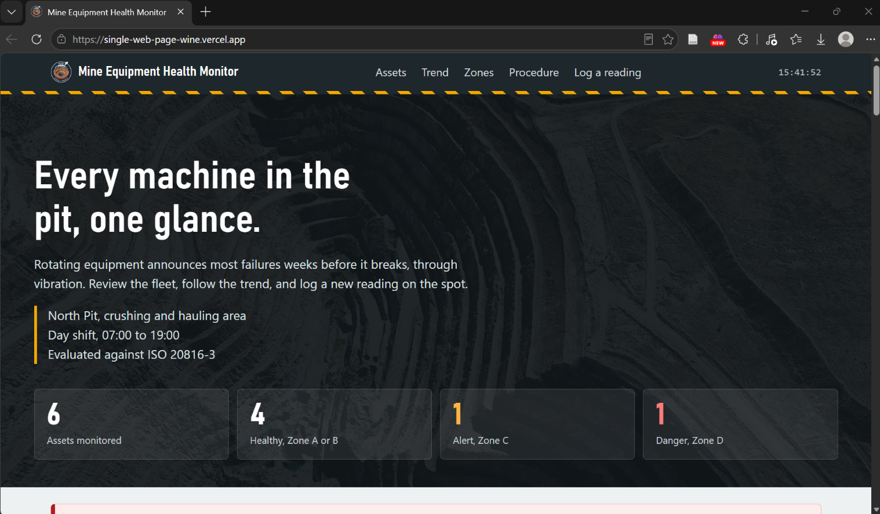

Figure 1. First screen on desktop: sticky header with hazard stripe, headline, site facts, and status counters.

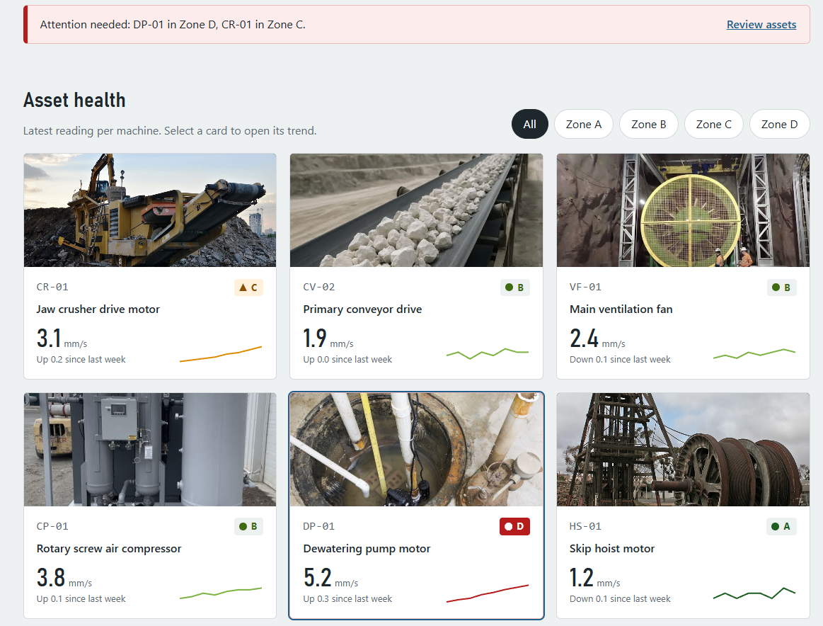

Figure 2. Alarm banner and asset cards with sparklines and zone badges; the Zone D card has a red border.

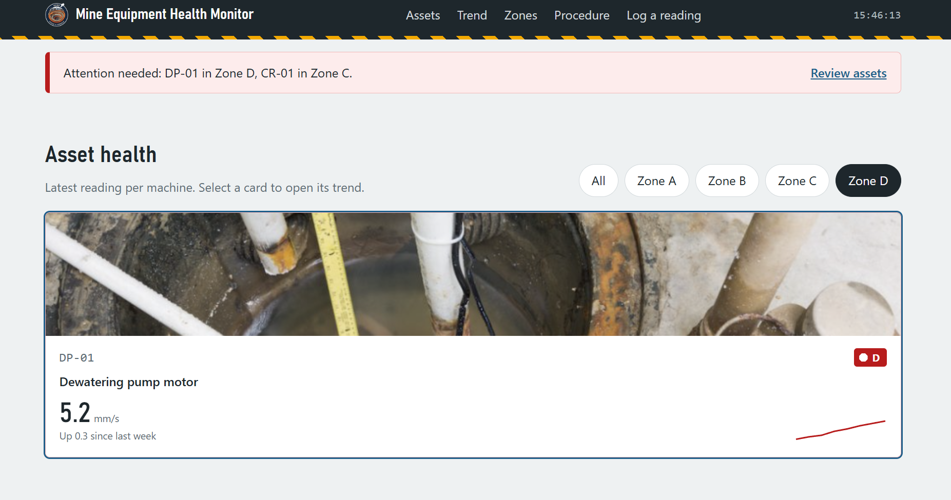

Figure 3. Zone filter set to Zone D, leaving only the dewatering pump card.

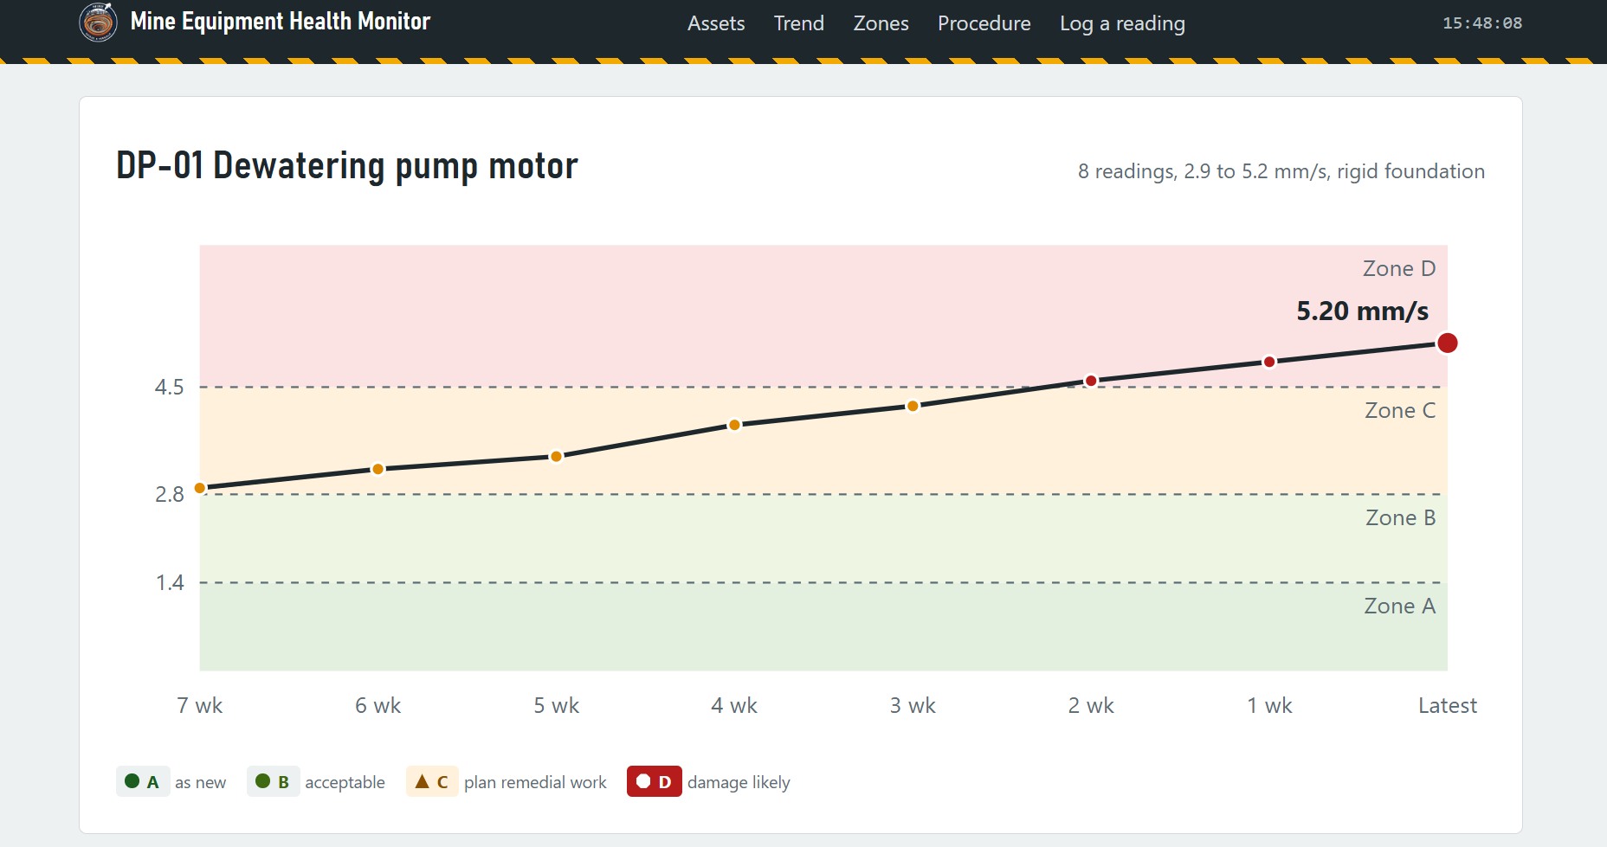

Figure 4. Trend chart of the selected machine with zone bands, dashed boundaries, and a time axis.

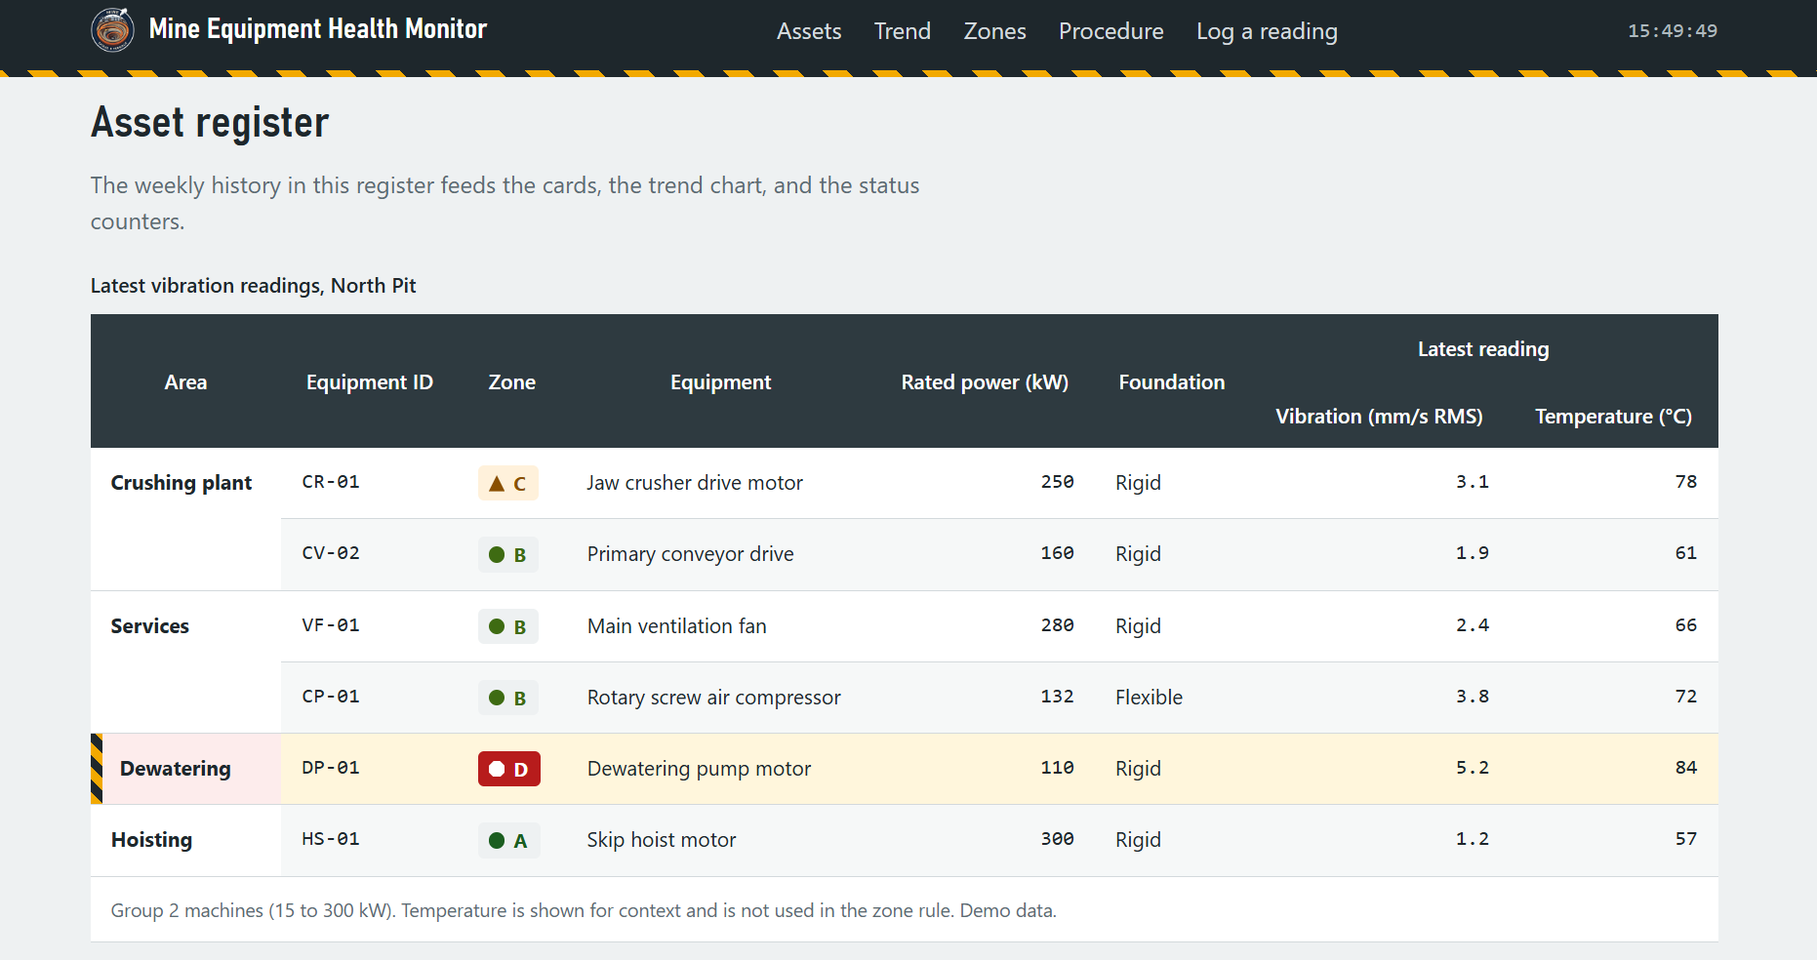

Figure 5. Asset register table with two header rows, area rowspans, and the striped Zone D row edge.

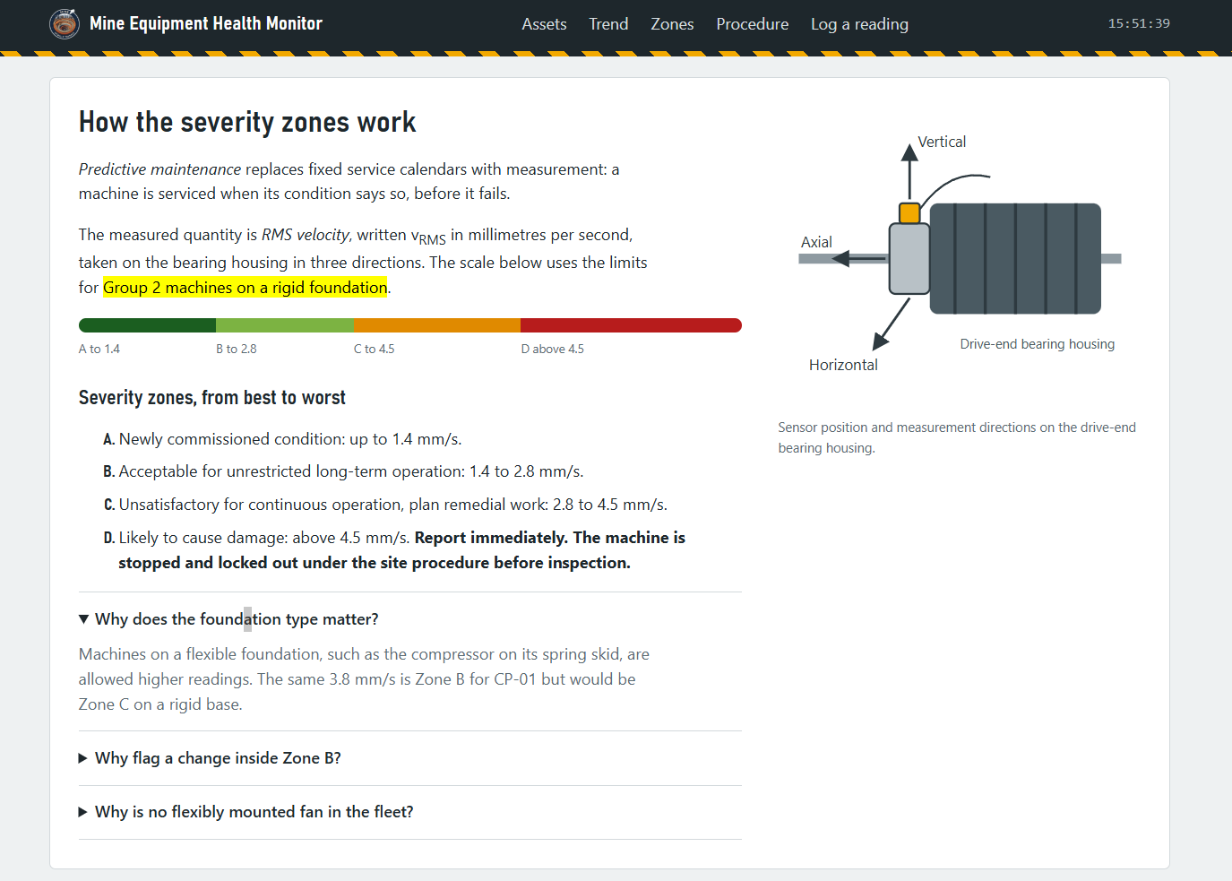

Figure 6. Severity zones: gauge scale, lettered ordered list, one expanded explanation, and the sensor diagram.

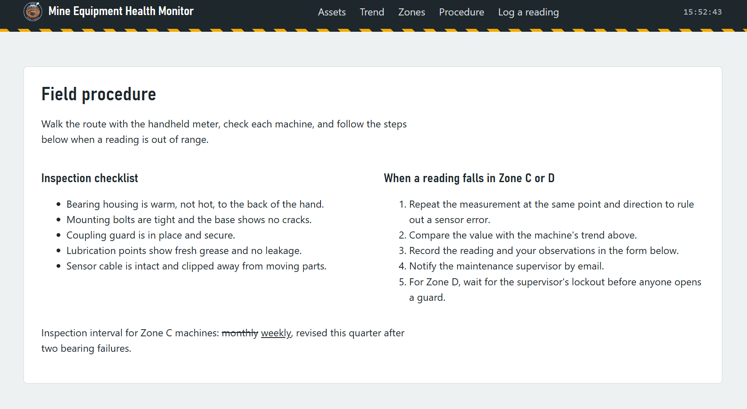

Figure 7. Field procedure: inspection checklist and escalation steps, with the revised inspection interval.

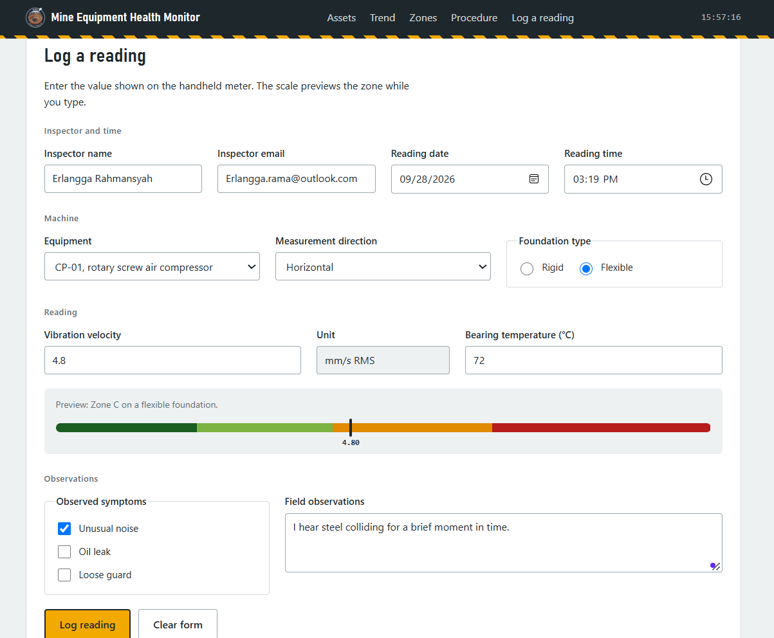

Figure 8. Log form with a filled reading and the live zone preview pointer in the Zone C band.

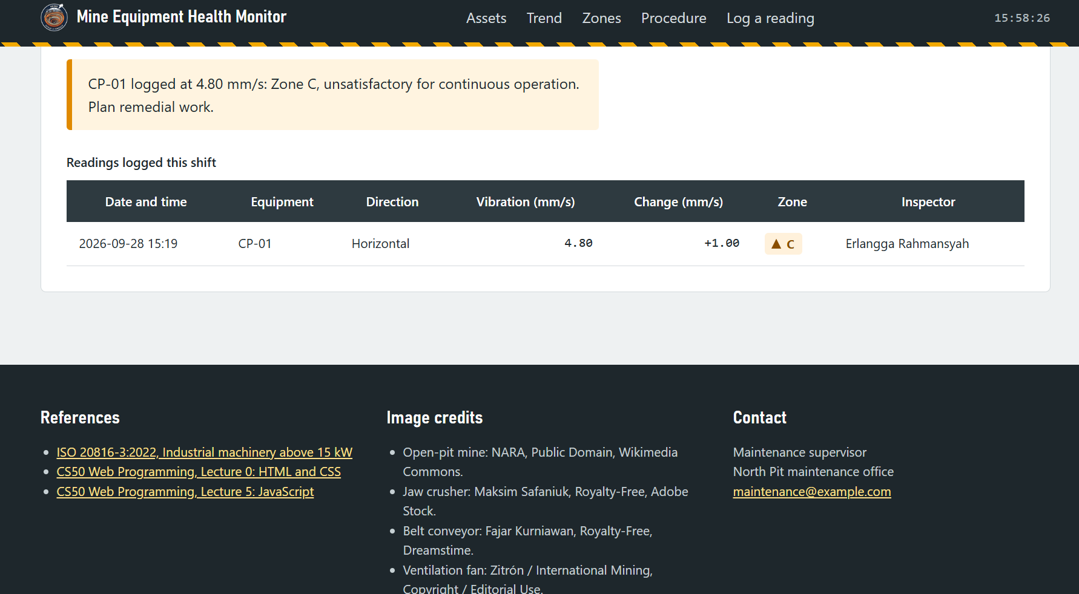

Figure 9. Result message for a logged reading, and the log table with the newest row on top.

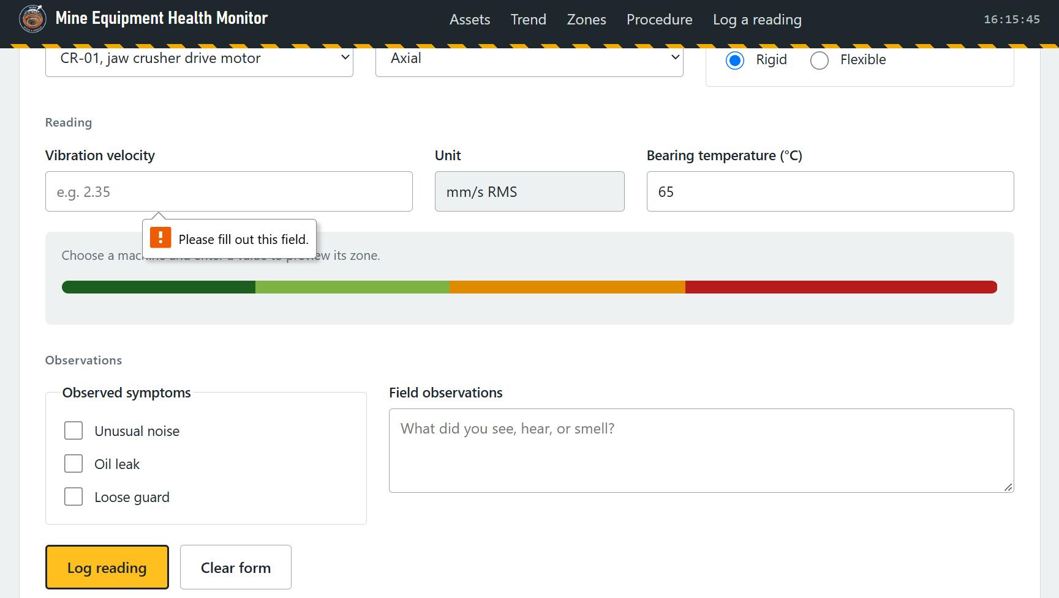

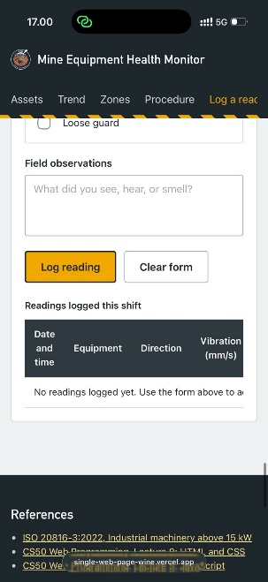
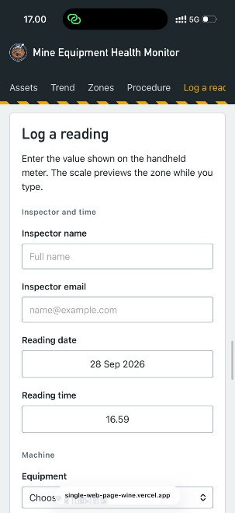
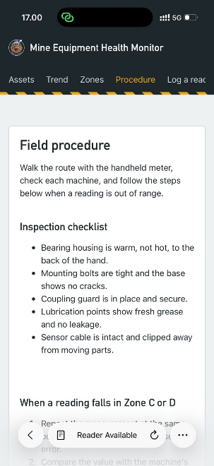
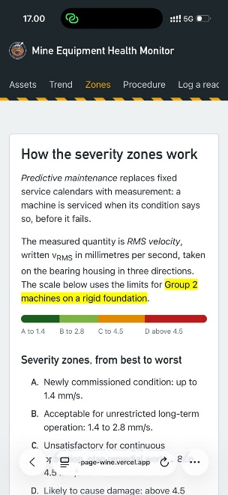
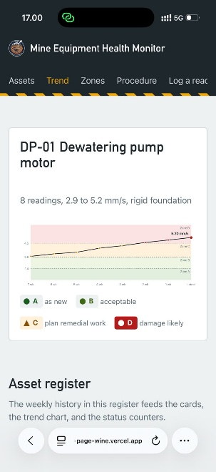
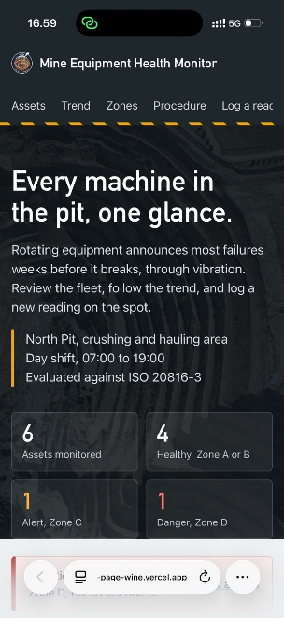
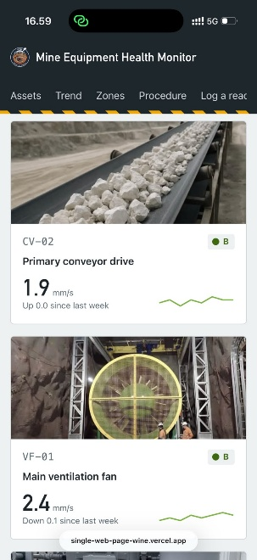
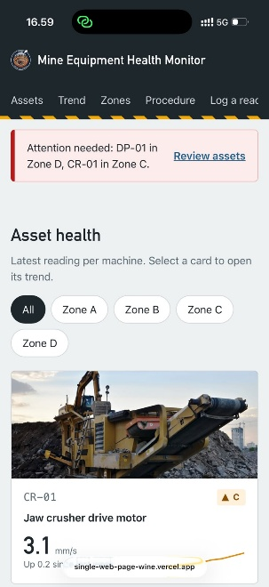
Figure 10. Native validation message after submitting the form with the vibration field empty.

Figure 11. Mobile view at 375 px: compact navigation, hero, status counters, and the first asset card.

User Guide
- Open Mine Equipment Health Monitor in Chrome, Edge, or Firefox with the images folder beside it. No installation or internet connection is needed.
- Read the status counters and the alarm banner. The banner names the machines in Zone D and Zone C and is hidden when none is abnormal.
- Use the zone chips to show only the cards of one zone. Select All to show every machine.
- Select a card. The trend chart shows the last eight readings of that machine against the zone bands, and the log form is pre-filled with the machine and its foundation type.
- To log a reading, choose the machine and the measurement direction, and enter the value from the meter in mm/s RMS. The scale under the temperature field shows the zone while you type.
- Enter your name once. It stays filled in for the next reading, together with your email. The date and time default to the current local time.
- Select Log reading. The result sentence states the zone and its meaning. If the value changed by more than a quarter of the B/C limit since the previous reading, the message also asks you to investigate.
- For Zone C or D, follow the steps in the Field procedure section. For Zone D, wait for the supervisor's lockout before anyone opens a guard.
- Clear form empties the reading fields. Logged readings return to their starting values when the page is refreshed, because nothing is stored on a server.

Requirement Compliance
Each requirement of Homework One is mapped to the elements and the lines of the source code in Appendix C.
    - Basic framework

Item | Implementation | Line
Page title | <title>Mine Equipment Health Monitor</title> | 6
Charset meta tag | <meta charset="UTF-8"> | 4
Viewport meta tag | width=device-width, initial-scale=1.0 | 5
Document language | <html lang="en"> | 2
    - Text elements

Item | Implementation | Lines
Multi-level headings | h1 headline, h2 per section, h3 sub-topics | 249; 276, 311,  376, 413; 383,  417, 427
Paragraphs | Explanatory text in every section | Throughout
Line breaks | Site facts and contact block | 252, 253, 585,  586
<strong> | Zone D instruction | 388
<em> | Key terms: predictive maintenance, RMS velocity | 377, 378
<mark> | Limit set currently applied | 378
<sub> | Quantity symbol vRMS | 378
<small> | Demo-data note | 365
<del> and <ins> | Inspection interval revised from monthly to weekly | 437
    - Lists and tables

Item | Implementation | Lines
Ordered list | Zones A to D (type="A") and escalation steps | 384, 428
Unordered list | Inspection checklist; navigation | 233, 418
Complete table | caption, thead, tbody, tfoot, th with scope | 316 to 368
Colspan | Latest reading header; footnote row | 326, 365, 550
Rowspan | Area names and two-row header | 318 to 322; 335,  344
Second table | Readings logged this shift | 541 to 552
    - Links and media resources
Item | Implementation | Lines
Internal links | Navigation bookmarks to section ids | 234 to 238
External links | target="_blank", rel="noopener", title | 564, 565, 566
Email link | mailto: supervisor | 587
Images | Hero photograph, sensor diagram, and six card photographs set by script, all with alt text | 247, 404
Inline SVG | Logo mark | 229

    - Forms

Item | Implementation | Lines
Input types (7) | text, email, number, date, time, radio, checkbox | 451, 455, 501,  459, 463, 492,  523
Input attributes (10) | required, placeholder, min, max, step, maxlength, readonly, autocomplete, value, checked | required 451; placeholder 451; min and  max 501; step  501; maxlength  451; readonly  505;  autocomplete 446; value 505;  checked 492
<select> | Equipment and measurement direction, each starting with an empty option | 470, 482
<textarea> | Field observations | 529
Labels and grouping | label for/id on every field; fieldset and legend | 489, 521
Buttons | Submit (Log reading) and reset (Clear form) | 533, 534
Functional behaviour | submit handler: validate, classify, log, redraw | 896 to 946
    - Styling
Item | Implementation | Lines
Internal style sheet | Single <style> block in <head> | 7 to 221
Link states | :link, :visited, :hover, :active in LVHA order | 31 to 34
Sticky position | Header stays visible | 39
Overflow | Horizontal scroll for tables on narrow screens | 121
Combinators | Child (.fleet tbody > tr, .row-zone-d > :first-child) and descendant (.card:hover .card-photo img) | 128, 131, 102
Pseudo-classes | :hover, :focus, :nth-child(even) | 35, 127
Pseudo-elements | ::before and ::after for hazard stripe and zone shapes; ::marker | 40, 62, 143
Flexbox | Header, hero counters, cards, split layouts, form rows | 41, 42, 44
Media queries | Mobile layout, reduced motion, print | 196, 211, 216

Discussion
Strengths
- One classification rule feeds every view, and the tests show that the register, cards, counters, alarm, and chart stay consistent after a new reading.
- Severity is encoded three times, by letter, shape, and colour, so the page stays readable for colour-blind users and in black-and-white print.
- The page has no dependencies. It opens from a file, works offline, and every construct in it can be traced to the course slides or to CS50 Web Lecture 5 [2][3][9].

Limitations
- The register values are illustrative. The page demonstrates the interface and the rule, not the condition of a real mine.
- The flexible-foundation limits (2.3, 4.5, 7.1 mm/s) come from secondary sources and must be confirmed against the published standard before any operational use.
- The change rule compares a reading with the previous reading of the same machine, not of the same measurement direction. The standard evaluates each direction separately.
- Nothing persists after a refresh, and there is no authentication. Both are deliberate for this homework.
- The classification supports a decision; it does not replace one. Stopping a machine remains a supervisor's decision under the site procedure.
Future work
- Move classify() to a Java Servlet and store readings in a database, so the log survives a refresh and is shared by a whole shift (Chapters 5 and 6).
- Keep a baseline per measurement direction, and plot the log entries into the trend chart.
- Confirm the flexible-foundation limits against the standard and add Group 1 machines above 300 kW.
- Add export of the log to CSV and a print layout for the shift report.

Conclusion
The Mine Equipment Health Monitor turns a Homework One checklist into a small but complete condition-monitoring interface. A single classification rule based on ISO 20816-3 drives the status counters, the alarm banner, the asset cards, the trend chart, and the reading form. The page uses only HTML, an internal stylesheet, and plain JavaScript, makes no network request, and passed sixteen tests. It satisfies all six requirements of the assignment and prepares the ground for the individual project, where the same rule and the same form will run on a Servlet and Spring MVC backend.

References
- ISO. ISO 20816-3:2022, Mechanical vibration: Measurement and evaluation of machine vibration, Part 3: Industrial machinery with a power rating above 15 kW and operating speeds between 120 r/min and 30 000 r/min. Geneva: ISO, 2022. https://www.iso.org/standard/78311.html
- Yu, B., and Malan, D. J. CS50's Web Programming with Python and JavaScript, Lecture 0: HTML and CSS. Harvard University. https://cs50.harvard.edu/web/notes/0/
- Yu, B., and Malan, D. J. CS50's Web Programming with Python and JavaScript, Lecture 5:
JavaScript. Harvard University. https://cs50.harvard.edu/web/notes/5/
- Fabrico. ISO 10816-3 Vibration Severity: Zones, Limits and How to Read Them. 2026. https://www.fabrico.io/blog/iso-10816-3-vibration-severity/
- Acoem USA. Understanding the ISO 10816-3 Vibration Severity Chart. 2025. https://acoem.us/blog/other-topics/understanding-the-iso-10816-3-vibration-severity-chart/
- ToolGrit. Vibration Analysis Basics Guide. 2026. https://www.toolgrit.com/guides/vibration-analysis-basics
- Vibromera. ISO 20816-3 Vibration Limits and Calculator. 2026. https://vibromera.eu/glossary/iso-20816-3/
- HMI Library. ISA-101 HMI Design Standard: A Guide. https://hmilibrary.com/standards/isa-101
- Web Application Development course slides, course_1 to course_8. Shandong University of Science and Technology, 2026.
- Merobix. What Is ISA-101 HMI Design? https://www.merobix.com/blog/what-is-isa-101-hmi-design
- Colour Blind Awareness. Colour Blindness. https://www.colourblindawareness.org/

Appendix A. Assignment Record and Version History

Item | Detail
Course | Web Application Development, Shandong University of Science and Technology
Assignment | Homework One, free topic, single page, six requirements (course_6, section 23)
Deadline | Wednesday evening, 30 September 2026
Report format | Printed on A4: design concept, interface display, user guide, complete source code
Course material used | course_1 to course_8 (HTML, CSS, forms, position, flexbox)
External learning source | CS50's Web Programming with Python and JavaScript, Lectures 0 and 5
Standard used for the domain rule | ISO 20816-3 (successor to ISO 10816-3)
Relation to other coursework | First front-end block of the individual project, Mining Equipment Monitoring Dashboard. It is unrelated to the group project of the practice course.

Version history
Version | Lines | Summary
1.0 | 501 | Baseline page satisfying the six requirements; form with classification and log
1.1 | 501 | Defensibility pass: slide-level CSS and JavaScript only; validator error fixed
2.0 | 971 | Interaction redesign: asset cards, trend chart, live preview, alarm, counters; assignment traces moved to this report

Appendix B. Image Credits
Fill in the final author, licence, and source of each photograph before printing, and copy the same text into the page footer (lines 572 to 579). Attribution requirements: CC BY and CC BY-SA require the author, the licence with a link, and a note of changes (cropped, desaturated); CC BY-SA also requires the modified image to stay under CC BY-SA. Public-domain works need no credit, but crediting them is good practice.
File | Subject | Candidate source (verify before use) | Licence
open-pit-mine.jpg | Open-pit mine with benches | Wikimedia Commons, Category:Open pit mining in the United States (U.S. National Archives, Documerica) | Verify (public domain expected)
cr-01-jaw-crusher.jpg | Jaw crusher | Wikimedia Commons, File:UG jaw crusher.jpg, Nuno Madeira Alves | CC BY-SA 4.0
cv-02-belt-conveyor.jpg | Belt conveyor | Wikimedia Commons, Dingle Bank Sand Quarry, Michael Ely (Geograph) | CC BY-SA 2.0
vf-01-ventilation-fan.jpg | Mine ventilation fan | CDC Public Health Image Library, image 9638 (CDC/NIOSH) | Public domain
cp-01-air-compressor.jpg | Rotary screw air compressor | Wikimedia Commons, Category:Air compressors | Verify
dp-01-dewatering-pump.jpg | Dewatering pump | Wikimedia Commons, Category:Water pumps | Verify
hs-01-hoist-headframe.jpg | Mine headframe | Wikimedia Commons, File:Anselmo Mine headframe (Butte, Montana, USA) 1.jpg, James St. John | CC BY 2.0
sensor-placement.svg | Sensor diagram | Original work for this page | Own work

Appendix C. Complete Source Code
File index.html, 971 lines. Head: lines 1 to 6. Internal style sheet: lines 7 to 221. Body: lines 222 to 592. Script: lines 593 to 969. The images are in the images folder and are not reproduced here.
  - <!DOCTYPE html>
  - <html lang="en">
  - <head>
  - <meta charset="UTF-8">
  - <meta name="viewport" content="width=device-width, initial-scale=1.0">
  - <title>Mine Equipment Health Monitor</title>
  - <style>
  - /* ===== 1. Tokens and base ===== */
  - :root {
  - --ink: #1E272C; --slate: #2E3A40; --steel: #5B6B73; --line: #D3D9DC;
  - --canvas: #EEF1F2; --panel: #FFFFFF; --amber: #F2A900; --accent: #1F5F8B;
  - --zone-a: #1B5E20; --zone-b: #7CB342; --zone-c: #E08A00; --zone-d: #B71C1C;
  - --heading: "Bahnschrift SemiCondensed", "Bahnschrift", "DIN Alternate", "Arial Narrow", sans-serif;
  - --body: "Segoe UI", system-ui, -apple-system, "PingFang SC", "Microsoft YaHei", sans-serif;
  - --mono: Consolas, "SF Mono", Menlo, monospace;
16 }
- * { box-sizing: border-box; }
- html { scroll-behavior: smooth; }
- body { margin: 0; background: var(--canvas); color: var(--ink); font: 16px/1.55 var(--body); }
- h1, h2, h3 { font-family: var(--heading); line-height: 1.12; margin: 0 0 12px; font-weight: 600; }
- h1 { font-size: 56px; }
- h2 { font-size: 30px; }
- h3 { font-size: 20px; margin-top: 24px; }
- p, li { max-width: 68ch; }
- small { font-size: 13px; color: var(--steel); }
- img { max-width: 100%; display: block; }
- .mono { font-family: var(--mono); letter-spacing: 0.02em; }
- .muted { color: var(--steel); } 29
- /* ===== 2. Links, focus, buttons ===== */
- a:link { color: var(--accent); }
- a:visited { color: #5A4E8C; }
- a:hover { color: var(--ink); }
- a:active { color: #000000; }
- a:focus, button:focus, input:focus, select:focus, textarea:focus, summary:focus { outline: 3px solid var(--accent); outline-offset: 2px; }
- button { font: inherit; cursor: pointer; } 37
- /* ===== 3. Header ===== */
- .site-header { position: sticky; top: 0; z-index: 20; background: var(--ink); color: #FFFFFF; }
- .site-header::after { content: ""; display: block; height: 5px; background: repeating-linear-gradient(45deg, var(--amber) 0 12px, var(--ink) 12px 24px); }
- .header-inner { display: flex; align-items: center; justify-content: space-between; gap: 8px 24px; flex-wrap: wrap; }
- .brand { display: flex; align-items: center; gap: 10px; margin: 0; padding: 12px 0; font-family: var(--heading); font-size: 19px; font-weight: 600; }
- .brand-mark { width: 26px; height: 26px; }
- .site-nav ul { display: flex; gap: 4px 22px; list-style: none; margin: 0; padding: 0; flex-wrap: wrap; }
- .site-nav a { display: inline-block; padding: 12px 0; color: #D5DCDF; text-decoration: none; transition: color 0.2s; }
- .site-nav a:hover { color: var(--amber); }
- .site-header a:focus { outline-color: var(--amber); }
- .clock { font-family: var(--mono); font-size: 14px; color: #AEB9BE; } 49
- /* ===== 4. Layout and reveal ===== */
- .wrap { max-width: 1160px; margin: 0 auto; padding: 0 24px; }
- main > section { scroll-margin-top: 80px; padding: 64px 0 0; }
- .section-head { display: flex; justify-content: space-between; align-items: flex-end; gap: 16px; flex-wrap: wrap; margin-bottom: 20px; }
- .section-head p { margin: 0; color: var(--steel); }
- .panel { background: var(--panel); border: 1px solid var(--line); border-radius: 6px; padding: 28px; }
- .reveal { opacity: 0; transform: translateY(18px); transition: opacity 0.6s ease, transform 0.6s ease; }
- .reveal.is-visible { opacity: 1; transform: none; } 58
- /* ===== 5. Hero ===== */
- .hero { position: relative; color: #FFFFFF; background: var(--slate); overflow: hidden; }
- .hero-img { position: absolute; inset: 0; width: 100%; height: 100%; object-fit: cover; filter: grayscale(60%) contrast(1.05); }
- .hero::before { content: ""; position: absolute; inset: 0; z-index: 1; background: rgba(20, 27, 31,
0.78); }

- .hero-content { position: relative; z-index: 2; padding: 88px 0 40px; }
- .hero h1 { max-width: 18ch; }
- .hero p { color: #DCE3E6; font-size: 18px; }
- .site-facts { border-left: 4px solid var(--amber); padding-left: 16px; font-size: 15px; }
- .stats { display: flex; flex-wrap: wrap; gap: 12px; margin-top: 36px; }
- .stat { flex: 1 1 200px; background: rgba(255, 255, 255, 0.07); border: 1px solid rgba(255, 255, 255, 0.16); border-radius: 6px; padding: 16px 18px; }
- .stat b { display: block; font-family: var(--heading); font-size: 44px; line-height: 1; }
- .stat span { font-size: 14px; color: #C6D0D4; }
- .stat.alert b { color: #FFB347; }
- .stat.danger b { color: #FF7B7B; } 73
- /* ===== 6. Alarm banner ===== */
- .alarm { display: none; align-items: center; gap: 14px; margin-top: 24px; padding: 14px 18px; background: #FDECEC; border: 1px solid #F1B8B8; border-left: 6px solid var(--zone-d); border-radius: 6px; }
- .alarm.is-active { display: flex; }
- .alarm p { margin: 0; }
- .alarm a { margin-left: auto; font-weight: 600; white-space: nowrap; } 79
- /* ===== 7. Zone badges (shape and letter, never colour alone) ===== */
- .badge { display: inline-flex; align-items: center; gap: 6px; padding: 2px 9px 2px 7px; border-radius: 4px; font-weight: 700; font-size: 13px; background: #EEF1F2; color: var(--ink); }
- .badge::before { content: ""; width: 11px; height: 11px; background: currentColor; }
- .zone-a { color: var(--zone-a); } .zone-a::before, .zone-b::before { border-radius: 50%; }
- .zone-b { color: #3E6B12; }
- .zone-c { color: #8A4F00; background: #FFF1DB; }
- .zone-c::before { clip-path: polygon(50% 0, 100% 100%, 0 100%); }
- .zone-d { color: #FFFFFF; background: var(--zone-d); }
- .zone-d::before { clip-path: polygon(30% 0, 70% 0, 100% 30%, 100% 70%, 70% 100%, 30% 100%, 0 70%, 0 30%);
}
89
- /* ===== 8. Asset cards and filter ===== */
- .filters { display: flex; gap: 8px; flex-wrap: wrap; }
- .chip { min-height: 40px; padding: 8px 16px; border: 1px solid var(--line); border-radius: 999px; background: var(--panel); color: var(--ink); transition: background-color 0.2s, border-color 0.2s; }
- .chip:hover { border-color: var(--steel); }
- .chip.is-active { background: var(--ink); border-color: var(--ink); color: #FFFFFF; }
- .asset-grid { display: flex; flex-wrap: wrap; gap: 18px; }
- .card { flex: 1 1 320px; display: flex; flex-direction: column; background: var(--panel); border: 1px solid var(--line); border-radius: 6px; overflow: hidden; text-align: left; padding: 0; color: inherit; transition: transform 0.25s, box-shadow 0.25s, border-color 0.25s; }
- .card:hover { transform: translateY(-4px); box-shadow: 0 10px 24px rgba(30, 39, 44, 0.12); }
- .card.is-selected { border-color: var(--accent); box-shadow: 0 0 0 2px var(--accent); }
- .card.is-danger { border-color: #F1B8B8; }
- .card-photo { height: 160px; overflow: hidden; background: var(--slate); }
- .card-photo img { width: 100%; height: 100%; object-fit: cover; filter: grayscale(35%); transition: transform 0.5s; }
- .card:hover .card-photo img { transform: scale(1.05); }
- .card-body { padding: 16px 18px 18px; }
- .card-top { display: flex; justify-content: space-between; align-items: center; gap: 8px; }
- .card-name { font-weight: 600; margin: 6px 0 12px; }
- .card-reading { display: flex; align-items: flex-end; justify-content: space-between; gap: 12px; }
- .card-value { font-family: var(--heading); font-size: 36px; line-height: 1; }
- .card-value span { font-family: var(--body); font-size: 13px; color: var(--steel); margin-left: 4px; }
- .trend-note { font-size: 13px; color: var(--steel); }
- .spark { width: 120px; height: 36px; }
- .is-hidden { display: none; } 112
- /* ===== 9. Trend chart ===== */
- .trend-head { display: flex; justify-content: space-between; gap: 16px; flex-wrap: wrap; align-items: baseline; }
- .trend-svg { width: 100%; height: auto; display: block; margin-top: 12px; }
- .trend-line { fill: none; stroke: var(--ink); stroke-width: 2.5; stroke-linejoin: round; stroke-dasharray: var(--len); stroke-dashoffset: var(--len); transition: stroke-dashoffset 1.2s ease; }
- .trend-line.is-drawn { stroke-dashoffset: 0; }
- .legend { display: flex; gap: 16px; flex-wrap: wrap; font-size: 13px; color: var(--steel); margin-top: 8px; }
119
- /* ===== 10. Tables ===== */
- .table-scroll { overflow-x: auto; }
- table { border-collapse: collapse; width: 100%; font-size: 14px; background: var(--panel); }
- caption { text-align: left; font-weight: 600; padding-bottom: 10px; }
- .scroll-hint { display: none; font-weight: 400; color: var(--steel); }
- th, td { border-bottom: 1px solid var(--line); padding: 12px 14px; text-align: left; vertical-align: top;
}
- thead th { background: var(--slate); color: #FFFFFF; font-weight: 600; border-bottom: 0; }

- tbody tr:nth-child(even) td { background: #F6F8F8; }
- .fleet tbody > tr:hover td { background: #FFF6DC; }
- td.num { text-align: right; font-family: var(--mono); }
- tfoot td { font-size: 13px; color: var(--steel); }
- .row-zone-d > :first-child { padding-left: 20px; background: repeating-linear-gradient(45deg, var(--amber) 0 6px, var(--ink) 6px 12px) left / 8px 100% no-repeat, #FDECEC; }
132
- /* ===== 11. Gauge and zone explanation ===== */
- .gauge { position: relative; margin: 18px 0 30px; }
- .gauge-bar { display: flex; height: 14px; border-radius: 7px; overflow: hidden; }
- .gauge-bar span { display: block; height: 100%; }
- .gauge-labels { display: flex; font-size: 12px; color: var(--steel); margin-top: 6px; }
- .gauge-labels span { flex: 1; }
- .gauge-pointer.is-empty { opacity: 0; }
- .gauge-pointer { position: absolute; top: -7px; left: 0; width: 4px; height: 28px; margin-left: -2px; background: var(--ink); border-radius: 2px; transition: left 0.5s ease; }
- .gauge-pointer::after { content: attr(data-value); position: absolute; top: 30px; left: 50%; transform: translateX(-50%); font: 600 12px var(--mono); white-space: nowrap; }
- .zone-list li { margin-bottom: 8px; }
- .zone-list li::marker { font-family: var(--heading); font-weight: 700; }
- details { border-top: 1px solid var(--line); padding: 14px 0; }
- details:last-of-type { border-bottom: 1px solid var(--line); }
- summary { cursor: pointer; font-weight: 600; }
- details p { margin: 10px 0 0; color: var(--steel); }
- .split { display: flex; flex-wrap: wrap; gap: 36px; align-items: flex-start; }
- .split > .text { flex: 1 1 460px; }
- .split > figure { flex: 0 1 360px; margin: 0; }
- figcaption { font-size: 13px; color: var(--steel); margin-top: 8px; } 152
- /* ===== 12. Form ===== */
- form { display: flex; flex-direction: column; gap: 22px; }
- .form-row { display: flex; flex-wrap: wrap; gap: 18px 24px; }
- .group-title { margin: 6px 0 -8px; font-size: 13px; letter-spacing: 0.04em; color: var(--steel); font-weight: 600; }
- .field { flex: 1 1 200px; display: flex; flex-direction: column; gap: 6px; }
- .field.narrow { flex: 0 1 150px; }
- .field.full { flex-basis: 100%; }
- label, legend { font-weight: 600; font-size: 15px; }
- input, select, textarea { font: inherit; color: inherit; min-height: 44px; padding: 8px 12px; border: 1px solid #9AA7AD; border-radius: 4px; background: var(--panel); transition: border-color 0.2s, box-shadow 0.2s;
}
- input:hover, select:hover, textarea:hover { border-color: var(--steel); }
- input[readonly] { background: var(--canvas); }
- fieldset { flex: 1 1 200px; border: 1px solid var(--line); border-radius: 4px; padding: 12px 16px; margin: 0; }
- .choice { display: flex; align-items: center; gap: 10px; min-height: 36px; font-weight: 400; }
- .choice input { min-height: 0; width: 20px; height: 20px; }
- .preview { background: var(--canvas); border-radius: 6px; padding: 14px 18px 4px; }
- .preview p { margin: 0; font-size: 14px; color: var(--steel); }
- .actions { display: flex; gap: 12px; }
- .inline-choices { display: flex; gap: 20px; flex-wrap: wrap; }
- .field.wide { flex: 2 1 380px; }
- .btn { min-height: 46px; padding: 10px 22px; border-radius: 4px; font-weight: 600; transition: background-color 0.2s, transform 0.1s; }
- .btn:active { transform: translateY(1px); }
- .btn-primary { background: var(--amber); color: var(--ink); border: 2px solid var(--ink); }
- .btn-primary:hover { background: #FFBF1F; }
- .btn-ghost { background: var(--panel); color: var(--ink); border: 1px solid #9AA7AD; }
- .result { margin: 24px 0 8px; padding: 14px 18px; border-left: 6px solid var(--line); background: var(--canvas); border-radius: 4px; }
- .result:empty { display: none; }
- .result.zone-a, .result.zone-b { border-left-color: var(--zone-a); background: #EEF6E9; color: var(--ink); }
- .result.zone-c { border-left-color: var(--zone-c); background: #FFF4E0; color: var(--ink); }
- .result.zone-d { border-left-color: var(--zone-d); background: #FDECEC; color: var(--ink); }
- .result.error { border-left-color: var(--zone-d); }
- .result::before { display: none; }
- #log .table-scroll { margin-top: 24px; } 185
- /* ===== 13. Footer ===== */
- .site-footer { margin-top: 80px; background: var(--ink); color: #C6D0D4; padding: 48px 0 32px; font-size: 14px; }
- .footer-cols { display: flex; flex-wrap: wrap; gap: 32px; }
- .footer-cols > div { flex: 1 1 280px; }
- .site-footer h2 { font-size: 20px; color: #FFFFFF; }
- .site-footer ul { padding-left: 18px; }

- .site-footer a:link, .site-footer a:visited { color: #FFE08A; }
- .site-footer a:hover { color: #FFFFFF; } 194
- /* ===== 14. Responsive, motion, print ===== */
- @media (max-width: 720px) {
- h1 { font-size: 40px; }
- h2 { font-size: 26px; }
- .wrap { padding: 0 16px; }
- .panel { padding: 20px; }
- .clock { display: none; }
- .site-nav { width: 100%; overflow-x: auto; }
- .site-nav ul { flex-wrap: nowrap; white-space: nowrap; }
- .hero-content { padding-top: 56px; }
- .stat { flex: 1 1 calc(50% - 6px); padding: 12px 14px; }
- .stat b { font-size: 34px; }
- .scroll-hint { display: inline; }
- caption { position: sticky; left: 0; max-width: calc(100vw - 74px); }
- main > section { scroll-margin-top: 110px; }
210 }
- @media (prefers-reduced-motion: reduce) {
- html { scroll-behavior: auto; }
- .reveal { opacity: 1; transform: none; transition: none; }
- .trend-line, .gauge-pointer, .card, .card-photo img { transition: none; }
215 }
- @media print {
- .site-header { position: static; }
- .site-nav, .actions, .filters { display: none; }
- .reveal { opacity: 1; transform: none; }
220 }
- </style>
- </head>
- <body>
224
- <!-- ===== Header ===== -->
- <header class="site-header">
- <div class="wrap header-inner">
- <p class="brand">
- <svg class="brand-mark" viewBox="0 0 26 26" aria-hidden="true"><path d="M2 22 L9 10 L13 16 L17 8 L24
22 Z" fill="#F2A900"/><path d="M2 22 H24" stroke="#FFFFFF" stroke-width="2"/></svg>
- Mine Equipment Health Monitor
231 </p>
- <nav class="site-nav" aria-label="Page sections">
- <ul>
- <li><a href="#assets">Assets</a></li>
- <li><a href="#trend">Trend</a></li>
- <li><a href="#severity">Zones</a></li>
- <li><a href="#procedure">Procedure</a></li>
- <li><a href="#log">Log a reading</a></li>
239 </ul>
- </nav>
- <span class="clock" id="clock" aria-label="Local time">--: </span>
- </div>
- </header>
244
- <!-- ===== Hero with fleet status ===== -->
- <section id="top" class="hero">
- <img class="hero-img" src="images/open-pit-mine.jpg" alt="Terraced benches and haul roads spiralling down into an open-pit mine" width="1600" height="900">
- <div class="wrap hero-content">
- <h1>Every machine in the pit, one glance.</h1>
- <p>Rotating equipment announces most failures weeks before it breaks, through vibration. Review the fleet, follow the trend, and log a new reading on the spot.</p>
251 | <p class="site-facts">
252 | North Pit, crushing and hauling area<br>
253 | Day shift, 07:00 to 19:00<br>
254 | Evaluated against ISO 20816-3
255 | </p>
256 | <div class="stats" aria-label="Fleet status">
257 | <div class="stat"><b data-count="total">0</b><span>Assets monitored</span></div>
258 | <div class="stat"><b data-count="healthy">0</b><span>Healthy, Zone A or B</span></div>
259 | <div class="stat alert"><b data-count="alert">0</b><span>Alert, Zone C</span></div>
260 | <div class="stat danger"><b data-count="danger">0</b><span>Danger, Zone D</span></div>
261 | </div>
262 | </div>
263 | </section>
264

265 <main class="wrap">
266
- <div class="alarm" id="alarm" role="alert">
- <p id="alarm-text"></p>
- <a href="#assets">Review assets</a>
- </div>
271
- <!-- ===== Asset cards ===== -->
- <section id="assets">
- <div class="section-head reveal">
- <div>
- <h2>Asset health</h2>
- <p>Latest reading per machine. Select a card to open its trend.</p>
- </div>
- <div class="filters" role="group" aria-label="Filter by zone">
- <button type="button" class="chip is-active" data-filter="all">All</button>
- <button type="button" class="chip" data-filter="A">Zone A</button>
- <button type="button" class="chip" data-filter="B">Zone B</button>
- <button type="button" class="chip" data-filter="C">Zone C</button>
- <button type="button" class="chip" data-filter="D">Zone D</button>
- </div>
- </div>
- <div class="asset-grid" id="asset-grid"></div>
- </section>
289
- <!-- ===== Trend chart ===== -->
- <section id="trend">
- <div class="panel reveal">
- <div class="trend-head">
- <h2 id="trend-title">Vibration trend</h2>
- <p class="muted" id="trend-summary"></p>
- </div>
- <svg class="trend-svg" id="trend-svg" viewBox="0 0 720 280" role="img" aria-labelledby="trend-title trend-summary"></svg>
- <div class="legend">
- <span><span class="badge zone-a">A</span> as new</span>
- <span><span class="badge zone-b">B</span> acceptable</span>
- <span><span class="badge zone-c">C</span> plan remedial work</span>
- <span><span class="badge zone-d">D</span> damage likely</span>
- </div>
- </div>
- </section>
306
- <!-- ===== Asset register table ===== -->
- <section id="fleet">
- <div class="section-head reveal">
- <div>
- <h2>Asset register</h2>
- <p>The weekly history in this register feeds the cards, the trend chart, and the status counters.</p>
- </div>
- </div>
- <div class="table-scroll reveal">
- <table class="fleet">
- <caption>Latest vibration readings, North Pit<span class="scroll-hint"> Scroll sideways for all columns.</span></caption>
- <thead>
- <tr>
- <th scope="col" rowspan="2">Area</th>
- <th scope="col" rowspan="2">Equipment ID</th>
- <th scope="col" rowspan="2">Zone</th>
- <th scope="col" rowspan="2">Equipment</th>
- <th scope="col" rowspan="2">Rated power (kW)</th>
- <th scope="col" rowspan="2">Foundation</th>
- <th scope="colgroup" colspan="2">Latest reading</th>
327 </tr>
- <tr>
- <th scope="col">Vibration (mm/s RMS)</th>
- <th scope="col">Temperature (°C)</th>
331 </tr>
- </thead>
- <tbody>
- <tr data-id="CR-01" data-foundation="rigid" data-history="2.1 2.2 2.3 2.4 2.6 2.7 2.9 3.1" data-photo="images/cr-01-jaw-crusher.jpg" data-alt="Jaw crusher at a mine processing plant">
- <th scope="rowgroup" rowspan="2">Crushing plant</th>

- <td class="mono">CR-01</td><td class="zone"></td><td class="name">Jaw crusher drive motor</td><td class="num">250</td><td>Rigid</td>
- <td class="num vib">3.1</td><td class="num">78</td>
338 </tr>
- <tr data-id="CV-02" data-foundation="rigid" data-history="1.8 1.9 1.7 1.9 1.8 2.0 1.9 1.9" data-photo="images/cv-02-belt-conveyor.jpg" data-alt="Inclined belt conveyor carrying crushed rock">
- <td class="mono">CV-02</td><td class="zone"></td><td class="name">Primary conveyor drive</td><td class="num">160</td><td>Rigid</td>
- <td class="num vib">1.9</td><td class="num">61</td>
342 </tr>
- <tr data-id="VF-01" data-foundation="rigid" data-history="2.2 2.3 2.2 2.4 2.3 2.4 2.5 2.4" data-photo="images/vf-01-ventilation-fan.jpg" data-alt="Large axial mine ventilation fan">
- <th scope="rowgroup" rowspan="2">Services</th>
- <td class="mono">VF-01</td><td class="zone"></td><td class="name">Main ventilation fan</td><td class="num">280</td><td>Rigid</td>
- <td class="num vib">2.4</td><td class="num">66</td>
347 </tr>
- <tr data-id="CP-01" data-foundation="flexible" data-history="3.2 3.3 3.5 3.4 3.6 3.7 3.7 3.8" data-photo="images/cp-01-air-compressor.jpg" data-alt="Packaged rotary screw air compressor">
- <td class="mono">CP-01</td><td class="zone"></td><td class="name">Rotary screw air compressor</td><td class="num">132</td><td>Flexible</td>
- <td class="num vib">3.8</td><td class="num">72</td>
351 </tr>
- <tr data-id="DP-01" data-foundation="rigid" data-history="2.9 3.2 3.4 3.9 4.2 4.6 4.9 5.2" data-photo="images/dp-01-dewatering-pump.jpg" data-alt="Pump drawing water out of a flooded pit">
- <th scope="row">Dewatering</th>
- <td class="mono">DP-01</td><td class="zone"></td><td class="name">Dewatering pump motor</td><td class="num">110</td><td>Rigid</td>
- <td class="num vib">5.2</td><td class="num">84</td>
356 </tr>
- <tr data-id="HS-01" data-foundation="rigid" data-history="1.1 1.2 1.1 1.2 1.2 1.1 1.3 1.2" data-photo="images/hs-01-hoist-headframe.jpg" data-alt="Steel headframe above a mine shaft">
- <th scope="row">Hoisting</th>
- <td class="mono">HS-01</td><td class="zone"></td><td class="name">Skip hoist motor</td><td class="num">300</td><td>Rigid</td>
- <td class="num vib">1.2</td><td class="num">57</td>
361 </tr>
- </tbody>
- <tfoot>
- <tr>
- <td colspan="8">Group 2 machines (15 to 300 kW). Temperature is shown for context and is not used in the zone rule. <small>Demo data.</small></td>
366 </tr>
- </tfoot>
- </table>
- </div>
- </section>
371
- <!-- ===== Severity zones ===== -->
- <section id="severity">
- <div class="panel split reveal">
- <div class="text">
- <h2>How the severity zones work</h2>
- <p><em>Predictive maintenance</em> replaces fixed service calendars with measurement: a machine is serviced when its condition says so, before it fails.</p>
- <p>The measured quantity is <em>RMS velocity</em>, written v<sub>RMS</sub> in millimetres per second, taken on the bearing housing in three directions. The scale below uses the limits for <mark>Group 2 machines on a rigid foundation</mark>.</p>
- <div class="gauge" aria-hidden="true">
- <div class="gauge-bar" id="scale-bar"></div>
- <div class="gauge-labels" id="scale-labels"></div>
- </div>
- <h3>Severity zones, from best to worst</h3>
- <ol class="zone-list" type="A">
- <li>Newly commissioned condition: up to 1.4 mm/s.</li>
- <li>Acceptable for unrestricted long-term operation: 1.4 to 2.8 mm/s.</li>
- <li>Unsatisfactory for continuous operation, plan remedial work: 2.8 to 4.5 mm/s.</li>
- <li>Likely to cause damage: above 4.5 mm/s. <strong>Report immediately. The machine is stopped and locked out under the site procedure before inspection.</strong></li>
389 </ol>
- <details>
- <summary>Why does the foundation type matter?</summary>
- <p>Machines on a flexible foundation, such as the compressor on its spring skid, are allowed higher readings. The same 3.8 mm/s is Zone B for CP-01 but would be Zone C on a rigid base.</p>
- </details>
- <details>

- <summary>Why flag a change inside Zone B?</summary>
- <p>A fast rise is a warning even while the level is still acceptable. The page flags any change larger than a quarter of the B/C limit since the previous reading.</p>
- </details>
- <details>
- <summary>Why is no flexibly mounted fan in the fleet?</summary>
- <p>The standard's criteria generally apply only to fans above 300 kW or fans that are not flexibly supported, so the fan here sits on a rigid base.</p>
- </details>
- </div>
- <figure>
- <img src="images/sensor-placement.svg" alt="Diagram of a sensor on the drive-end bearing housing with arrows for the vertical, horizontal, and axial measurement directions" width="360" height="300" loading="lazy">
- <figcaption>Sensor position and measurement directions on the drive-end bearing housing.</figcaption>
- </figure>
- </div>
- </section>
409
- <!-- ===== Field procedure ===== -->
- <section id="procedure">
- <div class="panel reveal">
- <h2>Field procedure</h2>
- <p>Walk the route with the handheld meter, check each machine, and follow the steps below when a reading is out of range.</p>
- <div class="split">
- <div class="text">
- <h3>Inspection checklist</h3>
- <ul>
- <li>Bearing housing is warm, not hot, to the back of the hand.</li>
- <li>Mounting bolts are tight and the base shows no cracks.</li>
- <li>Coupling guard is in place and secure.</li>
- <li>Lubrication points show fresh grease and no leakage.</li>
- <li>Sensor cable is intact and clipped away from moving parts.</li>
424 </ul>
- </div>
- <div class="text">
- <h3>When a reading falls in Zone C or D</h3>
- <ol>
- <li>Repeat the measurement at the same point and direction to rule out a sensor error.</li>
- <li>Compare the value with the machine's trend above.</li>
- <li>Record the reading and your observations in the form below.</li>
- <li>Notify the maintenance supervisor by email.</li>
- <li>For Zone D, wait for the supervisor's lockout before anyone opens a guard.</li>
434 </ol>
- </div>
- </div>
- <p>Inspection interval for Zone C machines: <del>monthly</del> <ins>weekly</ins>, revised this quarter after two bearing failures.</p>
- </div>
- </section>
440
- <!-- ===== Log a reading (form) ===== -->
- <section id="log">
- <div class="panel reveal">
- <h2>Log a reading</h2>
- <p>Enter the value shown on the handheld meter. The scale previews the zone while you type.</p>
- <form id="reading-form" autocomplete="on">
- <p class="group-title">Inspector and time</p>
- <div class="form-row">
- <div class="field">
- <label for="inspector">Inspector name</label>
- <input type="text" id="inspector" name="inspector" required maxlength="40" placeholder="Full name" autocomplete="name">
- </div>
- <div class="field">
- <label for="email">Inspector email</label>
- <input type="email" id="email" name="email" placeholder="name@example.com" autocomplete="email">
- </div>
- <div class="field">
- <label for="date">Reading date</label>
- <input type="date" id="date" name="date" required>
- </div>
- <div class="field">

- <label for="time">Reading time</label>
- <input type="time" id="time" name="time">
- </div>
- </div>
- <p class="group-title">Machine</p>
- <div class="form-row">
- <div class="field">
- <label for="equipment">Equipment</label>
- <select id="equipment" name="equipment" required>
- <option value="">Choose a machine</option>
- <option value="CR-01">CR-01, jaw crusher drive motor</option>
- <option value="CV-02">CV-02, primary conveyor drive</option>
- <option value="VF-01">VF-01, main ventilation fan</option>
- <option value="CP-01">CP-01, rotary screw air compressor</option>
- <option value="DP-01">DP-01, dewatering pump motor</option>
- <option value="HS-01">HS-01, skip hoist motor</option>
- </select>
- </div>
- <div class="field">
- <label for="direction">Measurement direction</label>
- <select id="direction" name="direction" required>
- <option value="">Choose a direction</option>
- <option value="Horizontal">Horizontal</option>
- <option value="Vertical">Vertical</option>
- <option value="Axial">Axial</option>
- </select>
- </div>
- <fieldset>
- <legend>Foundation type</legend>
- <div class="inline-choices">
- <label class="choice"><input type="radio" name="foundation" value="rigid" checked> Rigid</label>
- <label class="choice"><input type="radio" name="foundation" value="flexible"> Flexible</label>
- </div>
- </fieldset>
- </div>
- <p class="group-title">Reading</p>
- <div class="form-row">
- <div class="field">
- <label for="vibration">Vibration velocity</label>
- <input type="number" id="vibration" name="vibration" required min="0" max="20" step="0.01" placeholder="e.g. 2.35">
- </div>
- <div class="field narrow">
- <label for="unit">Unit</label>
- <input type="text" id="unit" name="unit" value="mm/s RMS" readonly>
- </div>
- <div class="field">
- <label for="temperature">Bearing temperature (°C)</label>
- <input type="number" id="temperature" name="temperature" min="-20" max="150" step="1" placeholder="e.g. 65">
- </div>
- </div>
- <div class="preview" aria-live="polite">
- <p id="preview-text">Choose a machine and enter a value to preview its zone.</p>
- <div class="gauge">
- <div class="gauge-bar" id="preview-bar"></div>
- <div class="gauge-pointer is-empty" id="preview-pointer" data-value=""></div>
- </div>
- </div>
- <p class="group-title">Observations</p>
- <div class="form-row">
- <fieldset>
- <legend>Observed symptoms</legend>
- <label class="choice"><input type="checkbox" name="symptom" value="Unusual noise"> Unusual noise</label>
- <label class="choice"><input type="checkbox" name="symptom" value="Oil leak"> Oil leak</label>
- <label class="choice"><input type="checkbox" name="symptom" value="Loose guard"> Loose guard</label>
- </fieldset>
- <div class="field wide">
- <label for="notes">Field observations</label>
- <textarea id="notes" name="notes" rows="3" maxlength="500" placeholder="What did you see, hear, or smell?"></textarea>
- </div>

- </div>
- <div class="actions">
- <button type="submit" class="btn btn-primary">Log reading</button>
- <button type="reset" class="btn btn-ghost">Clear form</button>
- </div>
- </form>
537
538 <p id="result" class="result" aria-live="polite"></p> 539
- <div class="table-scroll">
- <table class="log">
- <caption>Readings logged this shift</caption>
- <thead>
- <tr>
- <th scope="col">Date and time</th><th scope="col">Equipment</th><th scope="col">Direction</th>
- <th scope="col">Vibration (mm/s)</th><th scope="col">Change (mm/s)</th><th scope="col">Zone</th><th scope="col">Inspector</th>
547 </tr>
- </thead>
- <tbody id="log-body">
- <tr id="empty-row"><td colspan="7">No readings logged yet. Use the form above to add the first one.</td></tr>
- </tbody>
- </table>
- </div>
- </div>
- </section>
- </main>
557
- <!-- ===== Footer ===== -->
- <footer class="site-footer">
- <div class="wrap footer-cols">
- <div>
- <h2>References</h2>
- <ul>
- <li><a href="https://www.iso.org/standard/78311.html" target="_blank" rel="noopener" title="Opens in a new tab">ISO 20816-3:2022, Industrial machinery above 15 kW</a></li>
- <li><a href="https://cs50.harvard.edu/web/notes/0/" target="_blank" rel="noopener" title="Opens in a new tab">CS50 Web Programming, Lecture 0: HTML and CSS</a></li>
- <li><a href="https://cs50.harvard.edu/web/notes/5/" target="_blank" rel="noopener" title="Opens in a new tab">CS50 Web Programming, Lecture 5: JavaScript</a></li>
567 | </ul>
568 | </div>
569 | <div>
570 | <h2>Image credits</h2>
571 | <ul id="credits">
572 | <li>Open-pit mine: [author], [licence], [source].</li>
573 | <li>Jaw crusher: [author], [licence], [source].</li>
574 | <li>Belt conveyor: [author], [licence], [source].</li>
575 | <li>Ventilation fan: [author], [licence], [source].</li>
576 | <li>Air compressor: [author], [licence], [source].</li>
577 | <li>Dewatering pump: [author], [licence], [source].</li>
578 | <li>Hoist headframe: [author], [licence], [source].</li>
579 | <li>Sensor diagram and logo: original SVG.</li>
580 | </ul>
581 | </div>
582 | <div>
583 | <h2>Contact</h2>
584 | <p>
585 | Maintenance supervisor<br>
586 | North Pit maintenance office<br>
587 | <a href="mailto:maintenance@example.com">maintenance@example.com</a>
588 | </p>
589 | </div>
590 | </div>
591 | </footer>
592
593 | <script>
594 | // ===== Rules: ISO 20816-3, Group 2 (15 to 300 kW), mm/s RMS, boundaries [A/B, B/C, C/D] =====
595 | const LIMITS = {
596 | rigid: [1.4, 2.8, 4.5],
597 | flexible: [2.3, 4.5, 7.1]
598 | };
599 | const MEANING = {
600 | A: "newly commissioned condition.",

601 B: "acceptable for long-term operation.",
602 C: "unsatisfactory for continuous operation. Plan remedial work.",
603 D: "likely to cause damage. Report now; the machine must be locked out before inspection."
604 };
605 const ZONE_FILL = { A: "#E3EFDF", B: "#EEF5E3", C: "#FFF1DB", D: "#FBE3E3" };
606 const ZONE_BAR = { A: "#1B5E20", B: "#7CB342", C: "#E08A00", D: "#B71C1C" };
607
- // A value on a boundary belongs to the better zone (2.8 on rigid is Zone B).
- function classify(vibration, foundation) {
- const limit = LIMITS[foundation];
- if (vibration <= limit[0]) return "A";
- if (vibration <= limit[1]) return "B";
- if (vibration <= limit[2]) return "C";
- return "D";
615 }
616
- function badge(zone) {
- const span = document.createElement("span");
- span.className = `badge zone-${zone.toLowerCase()}`;
- span.textContent = zone;
- return span;
622 }
623
624 // ===== Scale helpers shared by the gauges =====
625 function scaleMax(foundation) {
626 return LIMITS[foundation][2] * 1.5;
627 }
628
- function drawScale(bar, foundation, labels) {
- const limit = LIMITS[foundation];
- const max = scaleMax(foundation);
- const edges = [0, limit[0], limit[1], limit[2], max];
- bar.textContent = "";
- if (labels) labels.textContent = "";
- ["A", "B", "C", "D"].forEach((zone, i) => {
- const part = document.createElement("span");
- part.style.width = `${((edges[i + 1] - edges[i]) / max) * 100}%`;
- part.style.background = ZONE_BAR[zone];
- bar.append(part);
- if (labels) {
- const label = document.createElement("span");
- label.style.flex = `0 0 ${((edges[i + 1] - edges[i]) / max) * 100}%`;
- label.textContent = i < 3 ? `${zone} to ${edges[i + 1]}` : `${zone} above ${edges[i]}`;
- labels.append(label);
645 }
646 });
647 }
648
- // ===== Sparkline and trend chart (plain SVG) =====
- const SVG_NS = "http://www.w3.org/2000/svg";
- function svgEl(tag, attrs) {
- const el = document.createElementNS(SVG_NS, tag);
- for (const key in attrs) el.setAttribute(key, attrs[key]);
- return el;
655 }
656
- function sparkline(values, zone) {
- const svg = svgEl("svg", { class: "spark", viewBox: "0 0 120 36", "aria-hidden": "true" });
- const max = Math.max(...values) * 1.1;
- const min = Math.min(...values) * 0.9;
- const points = values.map((v, i) => `${(i / (values.length - 1)) * 116 + 2},${34 - ((v - min) / (max - min)) * 32}`);
- svg.append(svgEl("polyline", { points: points.join(" "), fill: "none", stroke: ZONE_BAR[zone], "stroke-width": 2 }));
663 | return svg;
664 | }
665
666 | function drawTrend(machine) {
667 | const svg = document.querySelector("#trend-svg");
668 | const limit = LIMITS[machine.foundation];
669 | const max = Math.max(scaleMax(machine.foundation), Math.max(...machine.history) * 1.1);
670 | const left = 44, right = 700, top = 12, bottom = 236;
671 | const y = v => bottom - (v / max) * (bottom - top);
672 | const x = i => left + (i / (machine.history.length - 1)) * (right - left);
673 | svg.textContent = "";
674 | const edges = [0, limit[0], limit[1], limit[2], max];

675 ["A", "B", "C", "D"].forEach((zone, i) => {
676 svg.append(svgEl("rect", { x: left, y: y(edges[i + 1]), width: right - left, height: y(edges[i]) - y(edges[i + 1]), fill: ZONE_FILL[zone] }));
677 const tag = svgEl("text", { x: right - 6, y: y(edges[i + 1]) + 16, "text-anchor": "end", "font-size": 12, fill: "#5B6B73" });
678 tag.textContent = `Zone ${zone}`;
679 svg.append(tag);
680 });
- limit.forEach(value => {
- svg.append(svgEl("line", { x1: left, x2: right, y1: y(value), y2: y(value), stroke: "#5B6B73", "stroke-dasharray": "4 4" }));
- const tick = svgEl("text", { x: left - 8, y: y(value) + 4, "text-anchor": "end", "font-size": 12, fill: "#5B6B73" });
- tick.textContent = value;
- svg.append(tick);
686 });
- machine.history.forEach((v, i) => {
- const weeksAgo = machine.history.length - 1 - i;
- const axis = svgEl("text", { x: x(i), y: bottom + 22, "text-anchor": "middle", "font-size": 12, fill: "#5B6B73" });
- axis.textContent = weeksAgo === 0 ? "Latest" : `${weeksAgo} wk`;
- svg.append(axis);
692 });
- const points = machine.history.map((v, i) => `${x(i)},${y(v)}`).join(" ");
- const line = svgEl("polyline", { points, class: "trend-line" });
- svg.append(line);
- machine.history.forEach((v, i) => {
- svg.append(svgEl("circle", { cx: x(i), cy: y(v), r: i === machine.history.length - 1 ? 6 : 3.5, fill: ZONE_BAR[classify(v, machine.foundation)], stroke: "#FFFFFF", "stroke-width": 1.5 }));
698 });
- const latest = machine.history[machine.history.length - 1];
- const label = svgEl("text", { x: x(machine.history.length - 1) - 10, y: y(latest) - 12, "text-anchor": "end", "font-size": 14, "font-weight": 700, fill: "#1E272C" });
- label.textContent = `${latest.toFixed(2)} mm/s`;
- svg.append(label);
- const length = line.getTotalLength();
- line.style.setProperty("--len", length);
- requestAnimationFrame(() => requestAnimationFrame(() => line.classList.add("is-drawn"))); 706
707 const first = machine.history[0];
708 document.querySelector("#trend-title").textContent = `${machine.id} ${machine.name}`;
709 document.querySelector("#trend-summary").textContent =
710 `${machine.history.length} readings, ${first.toFixed(1)} to ${latest.toFixed(1)} mm/s, $
{machine.foundation} foundation`; 711 }
712
713 // ===== Count-up for the status strip =====
714 function countUp(el, target) {
715 const start = performance.now();
716 const reduce = window.matchMedia("(prefers-reduced-motion: reduce)").matches;
717 function step(now) {
718 const progress = reduce ? 1 : Math.min((now - start) / 900, 1);
719 el.textContent = Math.round(target * (1 - Math.pow(1 - progress, 3)));
720 if (progress < 1) requestAnimationFrame(step);
721 }
722 requestAnimationFrame(step);
723 }
724
725 // Local date and time (toISOString alone would give UTC, a day behind before 08:00 in China).
726 function localStamp() {
727 const now = new Date();
728 return new Date(now.getTime() - now.getTimezoneOffset() * 60000).toISOString();
729 }
730
- document.addEventListener("DOMContentLoaded", () => {
- const form = document.querySelector("#reading-form");
- const result = document.querySelector("#result");
- const logBody = document.querySelector("#log-body");
- const grid = document.querySelector("#asset-grid");
- const fleet = {};
- let selectedId = ""; 738
739 // 1. Read the asset register (single source of truth for every view).
740 document.querySelectorAll(".fleet tbody tr").forEach(row => {
741 const history = row.dataset.history.split(" ").map(Number);
742 fleet[row.dataset.id] = {

743 | id: row.dataset.id,
744 | name: row.querySelector(".name").textContent,
745 | foundation: row.dataset.foundation,
746 | history, row,
747 | photo: row.dataset.photo, alt: row.dataset.alt
748 | };
749 | });
750
751 | function latest(machine) {
752 | return machine.history[machine.history.length - 1];
753 | }
755 | // 2. Refresh everything that depends on the fleet state.
756 | function renderFleet(animate) {
757 | const counts = { total: 0, healthy: 0, alert: 0, danger: 0 };
758 | const warnings = [];
759 | grid.textContent = "";
760 | Object.values(fleet).forEach(machine => {
761 | const value = latest(machine);
762 | const zone = classify(value, machine.foundation);
763 | counts.total += 1;
764 | if (zone === "A" || zone === "B") counts.healthy += 1;
765 | if (zone === "C") { counts.alert += 1; warnings.push(`${machine.id} in Zone C`); }
766 | if (zone === "D") { counts.danger += 1; warnings.unshift(`${machine.id} in Zone D`); }
768 | const cell = machine.row.querySelector(".zone");
769 | cell.textContent = "";
770 | cell.append(badge(zone));
771 | machine.row.querySelector(".vib").textContent = value.toFixed(1);
772 | machine.row.classList.toggle("row-zone-d", zone === "D");
774 | const card = document.createElement("button");
775 | card.type = "button";
776 | card.className = "card";
777 | card.dataset.zone = zone;
778 | card.dataset.id = machine.id;
779 | if (zone === "D") card.classList.add("is-danger");
780 | if (machine.id === selectedId) card.classList.add("is-selected");
781 | const photo = document.createElement("div");
782 | photo.className = "card-photo";
783 | const img = document.createElement("img");
784 | img.src = machine.photo;
785 | img.alt = machine.alt;
786 | img.loading = "lazy";
787 | photo.append(img);
788 | const body = document.createElement("div");
789 | body.className = "card-body";
790 | const topRow = document.createElement("div");
791 | topRow.className = "card-top";
792 | const id = document.createElement("span");
793 | id.className = "mono muted";
794 | id.textContent = machine.id;
795 | topRow.append(id, badge(zone));
796 | const name = document.createElement("p");
797 | name.className = "card-name";
798 | name.textContent = machine.name;
799 | const reading = document.createElement("div");
800 | reading.className = "card-reading";
801 | const valueBox = document.createElement("div");
802 | const big = document.createElement("div");
803 | big.className = "card-value";
804 | big.textContent = value.toFixed(1);
805 | const unit = document.createElement("span");
806 | unit.textContent = "mm/s";
807 | big.append(unit);
808 | const change = value - machine.history[machine.history.length - 2];
809 | const note = document.createElement("div");
810 | note.className = "trend-note";
811 | note.textContent = `${change >= 0 ? "Up" : "Down"} ${Math.abs(change).toFixed(1)} since last week`;
812 | valueBox.append(big, note);
813 | reading.append(valueBox, sparkline(machine.history, zone));
814 | body.append(topRow, name, reading);
815 | card.append(photo, body);
816 | card.addEventListener("click", () => selectMachine(machine.id, true, true));
817 | grid.append(card);
818 | });

754

767

773

819 applyFilter();
820
821 document.querySelectorAll("[data-count]").forEach(el => {
822 const target = counts[el.dataset.count];
823 if (animate) countUp(el, target);
824 else el.textContent = target;
825 });
826 const alarm = document.querySelector("#alarm");
827 alarm.classList.toggle("is-active", warnings.length > 0);
828 document.querySelector("#alarm-text").textContent =
829 warnings.length ? `Attention needed: ${warnings.join(", ")}.` : "";
830 }
831
- // 3. Filter chips (show or hide cards by zone).
- let filter = "all";
- function applyFilter() {
- grid.querySelectorAll(".card").forEach(card => {
- card.classList.toggle("is-hidden", filter !== "all" && card.dataset.zone !== filter);
837 });
838 }
- document.querySelectorAll(".chip").forEach(chip => {
- chip.addEventListener("click", () => {
- filter = chip.dataset.filter;
- document.querySelectorAll(".chip").forEach(c => c.classList.toggle("is-active", c === chip));
- applyFilter();
844 });
845 });
846
- // 4. Selecting a machine links the card, the chart, and the form.
- // fillForm is false on page load, so the form is never pre-filled without a user action.
- function selectMachine(id, scroll, fillForm) {
- selectedId = id;
- grid.querySelectorAll(".card").forEach(card => card.classList.toggle("is-selected", card.dataset.id
=== id));
- drawTrend(fleet[id]);
- if (fillForm) {
- form.equipment.value = id;
- form.querySelector(`input[name="foundation"][value="${fleet[id].foundation}"]`).checked = true;
- updatePreview();
857 }
858 if (scroll) document.querySelector("#trend").scrollIntoView();
859 }
860
- // 5. Live zone preview while typing.
- const previewBar = document.querySelector("#preview-bar");
- const pointer = document.querySelector("#preview-pointer");
- function updatePreview() {
- const foundation = form.foundation.value;
- drawScale(previewBar, foundation);
- const value = parseFloat(form.vibration.value);
- const text = document.querySelector("#preview-text");
- if (isNaN(value)) {
- pointer.classList.add("is-empty");
- pointer.dataset.value = "";
- text.textContent = "Choose a machine and enter a value to preview its zone.";
- return;
874 }
- const max = scaleMax(foundation);
- pointer.classList.remove("is-empty");
- pointer.style.left = `${Math.min(value / max, 1) * 100}%`;
- pointer.dataset.value = value.toFixed(2);
- text.textContent = `Preview: Zone ${classify(value, foundation)} on a ${foundation} foundation.`;
880 }
881 form.vibration.addEventListener("input", updatePreview);
882 form.querySelectorAll('input[name="foundation"]').forEach(radio => radio.addEventListener("change", updatePreview));
883 | form.equipment.addEventListener("change", () => {
884 | if (fleet[form.equipment.value]) selectMachine(form.equipment.value, false, true);
885 | });
886
887 | function setNowDefaults() {
888 | const stamp = localStamp();
889 | form.date.value = stamp.slice(0, 10);
890 | form.time.value = stamp.slice(11, 16);
891 | }
892 | setNowDefaults();

893 form.addEventListener("reset", () => setTimeout(() => { setNowDefaults(); updatePreview(); }, 0)); 894
- // 6. Classify and log a reading; every view updates from the fleet state.
- form.addEventListener("submit", event => {
- event.preventDefault();
- const id = form.equipment.value;
- const vibration = Number(form.vibration.value);
- const foundation = form.foundation.value;
- result.className = "result";
- if (!(vibration >= 0 && vibration <= 20)) {
- result.classList.add("error");
- result.textContent = "Enter a vibration value between 0 and 20 mm/s.";
- return;
906 }
- const zone = classify(vibration, foundation);
- const previous = latest(fleet[id]);
- const change = vibration - previous;
- const bigChange = Math.abs(change) > 0.25 * LIMITS[foundation][1];
- fleet[id].history.push(vibration);
912
- const row = document.createElement("tr");
- const cells = [`${form.date.value} ${form.time.value}`.trim(), id, form.direction.value,
- vibration.toFixed(2), (change >= 0 ? "+" : "") + change.toFixed(2), null, form.inspector.value];
- cells.forEach((value, index) => {
- const td = document.createElement("td");
- if (index === 3 || index === 4) td.className = "num";
- if (value === null) td.append(badge(zone));
- else td.textContent = value; // textContent: typed text can never become markup
- row.append(td);
922 });
923 if (zone === "D") row.classList.add("row-zone-d");
924 const emptyRow = document.querySelector("#empty-row");
925 if (emptyRow) emptyRow.remove();
926 logBody.prepend(row);
927
928 let message = `${id} logged at ${vibration.toFixed(2)} mm/s: Zone ${zone}, ${MEANING[zone]}`;
929 if (bigChange && zone !== "D") {
930 message += ` The change of ${change.toFixed(2)} mm/s since the previous reading is larger than a quarter of the B/C limit. Investigate the cause.`;
931 }
932 result.classList.add(`zone-${zone.toLowerCase()}`);
933 result.textContent = message; 934
- renderFleet(false);
- selectMachine(id, false, false);
- // Keep who and when; clear only what changes per machine.
- ["vibration", "temperature", "notes"].forEach(name => { form[name].value = ""; });
- form.querySelectorAll('input[name="symptom"]').forEach(box => { box.checked = false; });
- form.direction.value = "";
- setNowDefaults();
- updatePreview();
- form.vibration.focus();
944 });
945
- // 7. Reveal sections as they scroll into view.
- const observer = new IntersectionObserver(entries => {
- entries.forEach(entry => {
- if (entry.isIntersecting) {
- entry.target.classList.add("is-visible");
- observer.unobserve(entry.target);
952 }
953 });
954 }, { threshold: 0.12 });
955 document.querySelectorAll(".reveal").forEach(el => observer.observe(el)); 956
- // 8. Shift clock in the header.
- const clock = document.querySelector("#clock");
- function tick() { clock.textContent = localStamp().slice(11, 19); }
- tick();
- setInterval(tick, 1000);
962
- drawScale(document.querySelector("#scale-bar"), "rigid", document.querySelector("#scale-labels"));
- renderFleet(true);
- const worst = Object.values(fleet).sort((a, b) => latest(b) - latest(a))[0];
- selectMachine(worst.id, false, false);
- updatePreview();

968 });
969 </script>
970 </body>
971 </html>

